PUBLIC SPACE PROTECTION ORDER

Section 59 Anti-Social Behaviour Crime and Policing Act 2014

- Following representations from members of the public and in relation to evidence that has been gathered and reviewed, the Tamworth Community Safety Partnership (lead agency Tamworth Borough Council), intends to apply a Public Spaces Protection Order on the area defined below:

Access Road to Dosthill Hall, Dosthill Park, Blackwood Road,Tamworth, B77 1LJ

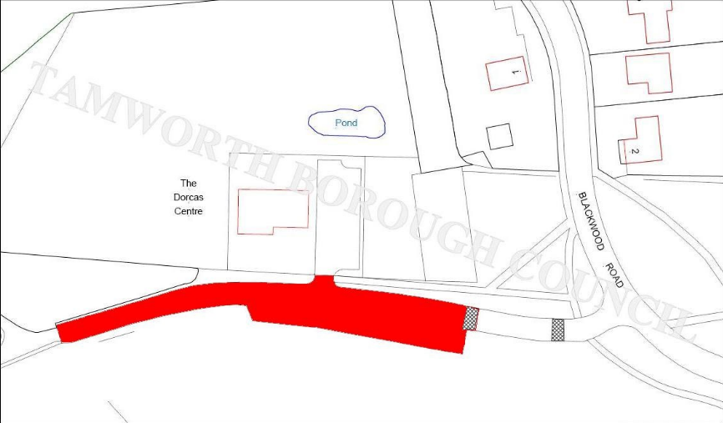

- Under the terms and restrictions of the Public Spaces Protection Order the following is PROHIBITED:

  - The playing of music emitting from any vehicle or by means of portable amplified device between the hours of 20:00 and 06:00 Monday – Sunday except with the express permission of Tamworth Borough Council
  - Congregating and loitering in groups around (or in) one or more vehicles and engaging in behaviour which is likely to cause noise, harassment, alarm or distress between the hours of 20:00 and 06:00 Monday-Sunday
  - Barbeques or littering
  - ‘Doughnutting’, racing or other vehicle nuisance
  - The drinking of alcohol in the area defined and breach on failure to comply with a request by an authorised officer to cease drinking or surrender alcohol

Parking of vehicles is permitted at all times by legitimate users of the play facility, Dorcas Centre, private residents and their visitors subject to compliance with conditions at 2(a) above

- If any local resident or member of the public is found to be committing the acts that are prohibited above, the following sanctions may be applied:
- The issue of a £100 Fixed Penalty Notice payable within 28 days and/or
- Prosecution for breach of an Order and a maximum penalty fine not exceeding level 3 on the standard scale (currently £1,000)

- It is the intention that this Public Spaces Protection Order will renew from 1st February 2020 and will expire on 31st January 2023. (Previous Order 1st December 2015 – 30th November 2018)

- If any interested person desires to question the validity of this Order on the grounds that the Council had no power to make it or that any requirement of the Act has not be complied with in relation to this Order, he or she may apply to the High Court within six weeks from the date on which this order is made.

