Belgrave Ward

Existing Polling Districts

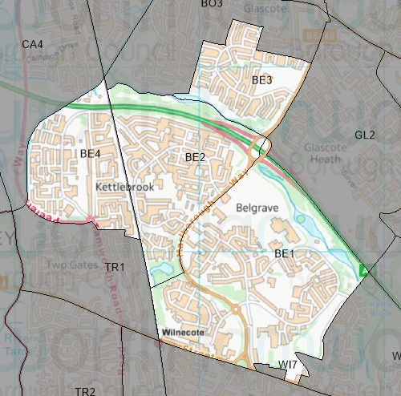

Existing Polling Stations
Polling District | Polling Station | Electorate | Polling Station Electorate | Disabled Access | What3Words Reference
BE1 | The Sports Centre, Tamworth Enterprise College | 1,825 | 1,550 | Yes | ///prices.guess.study
BE2 | Tamworth Baptist Church | 1,525 | 1,325 | Yes | ///really.incomes.pads
BE3 | Lakeside Primary School | 946 | 779 | Yes | ///view.remove.vines
BE4 | Park Farm Community Centre | 1,369 | 1,140 | Yes | ///shows.pays.look

Proposed Changes

Polling District | Polling Station | Recommendations
BE1 | The Sports Centre, Tamworth Enterprise College | No change.
BE2 | Tamworth Baptist Church | No change.
BE3 | Lakeside Primary School | No change.
BE4 | Park Farm Community Centre | No change.

No negative comments or complaints have been received regarding the polling districts or polling stations at recent elections. Therefore, no changes are proposed.

Belgrave Ward Polling Stations

BE1 – The Sports Centre, Tamworth Enterprise College

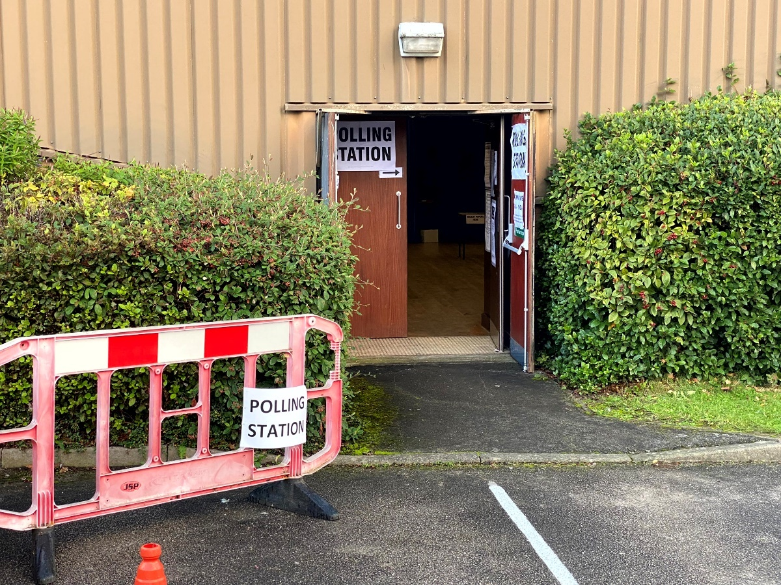

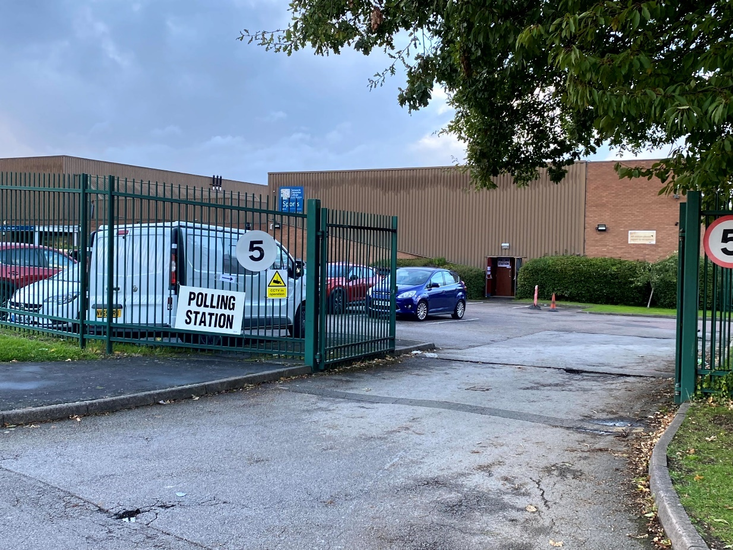

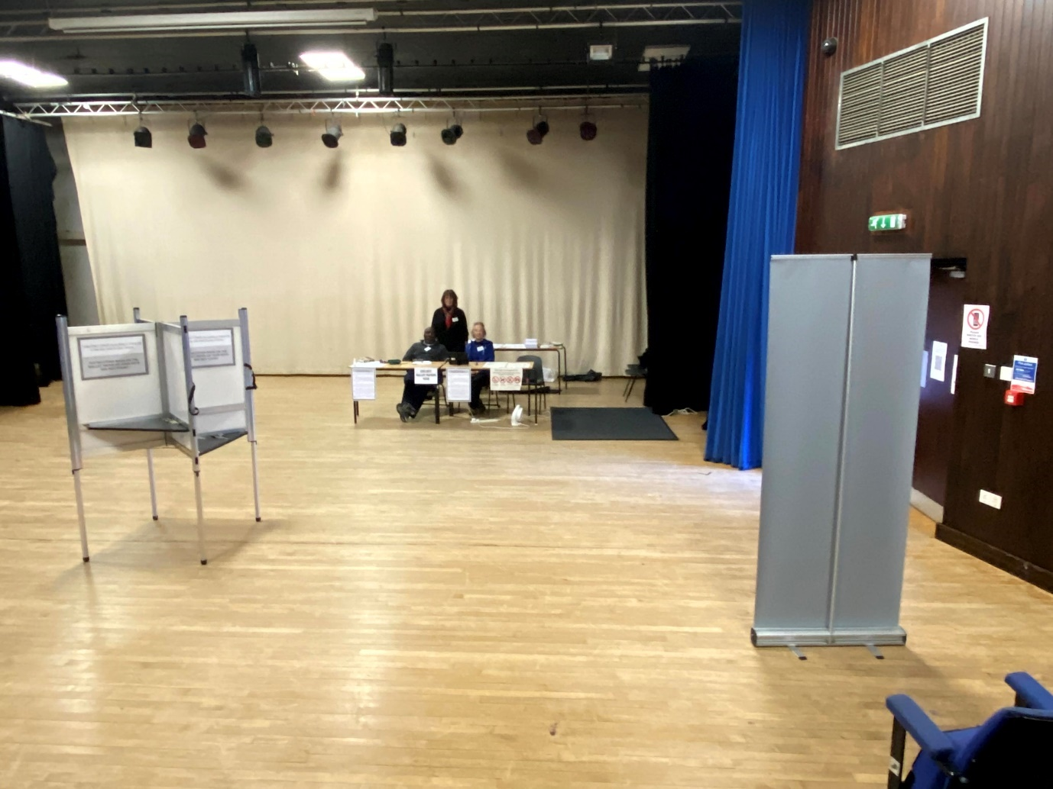

BE2 – Tamworth Baptist Church

BE3 – Lakeside Primary School

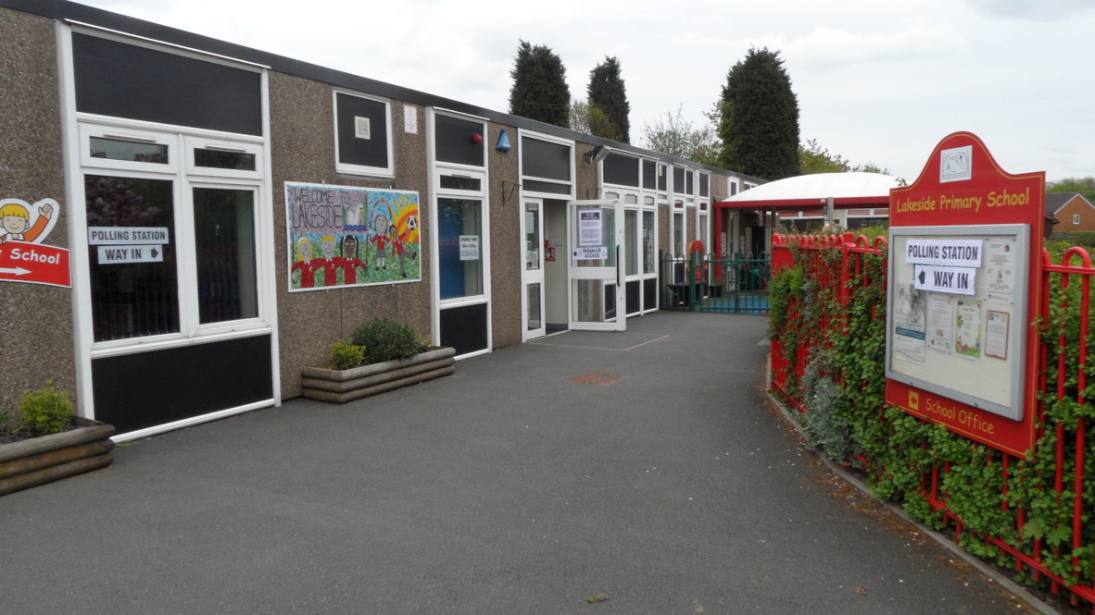

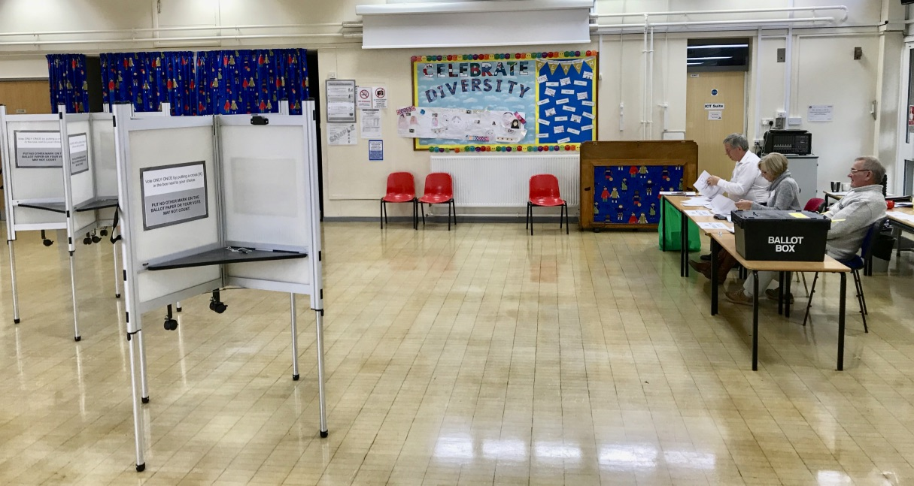

BE4 – Park Farm Community Centre

