Bolehall Ward

Existing Polling Districts

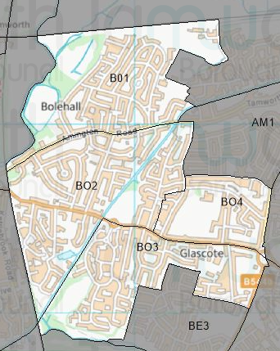

Existing Polling Stations
Polling District | Polling Station | Electorate | Polling Station Electorate | Disabled Access | What3Words Reference
BO1 | Bolehall Swifts Social Club | 1,301 | 1,084 | Yes | ///exists.decent.light
BO2 | William Macgregor Primary School | 2,183 | 1,827 | Yes | ///driven.flips.values
BO3 | Glascote Meeting Rooms | 1,428 | 1,224 | Yes | ///drums.scars.foster
BO4 | Woodlands Primary School | 738 | 625 | Yes | ///script.socket.begin

Proposed Changes

Polling District | Polling Station | Recommendations
BO1 | Bolehall Swifts Social Club | No change.
BO2 | William Macgregor Primary School | No change.
BO3 | Glascote Meeting Rooms | No change.
BO4 | Woodlands Primary School | No change.

No negative comments or complaints have been received regarding the polling districts or polling stations at recent elections. Therefore, no changes are proposed.

Bolehall Ward Polling Stations

BO1 – Bolehall Swifts Social Club
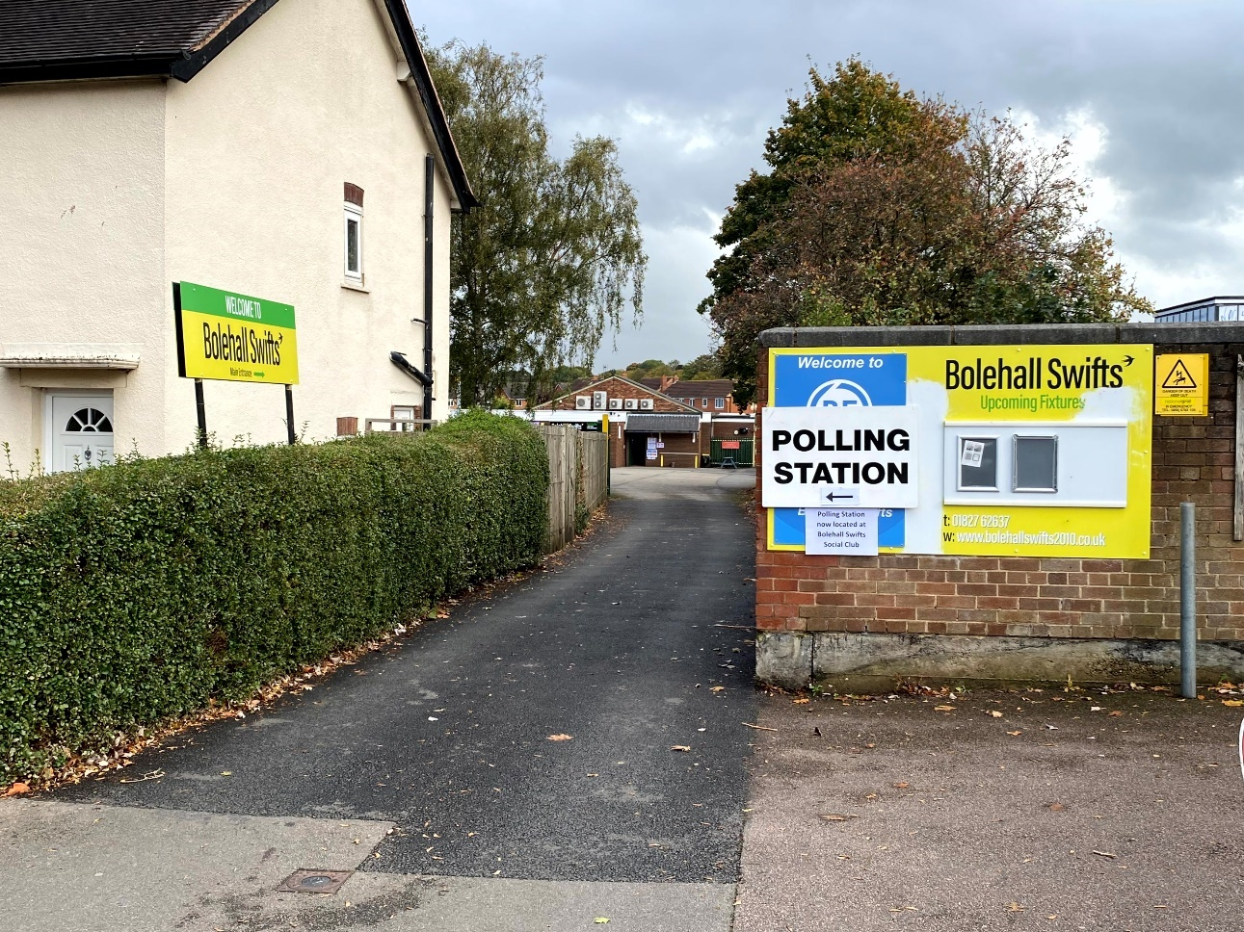

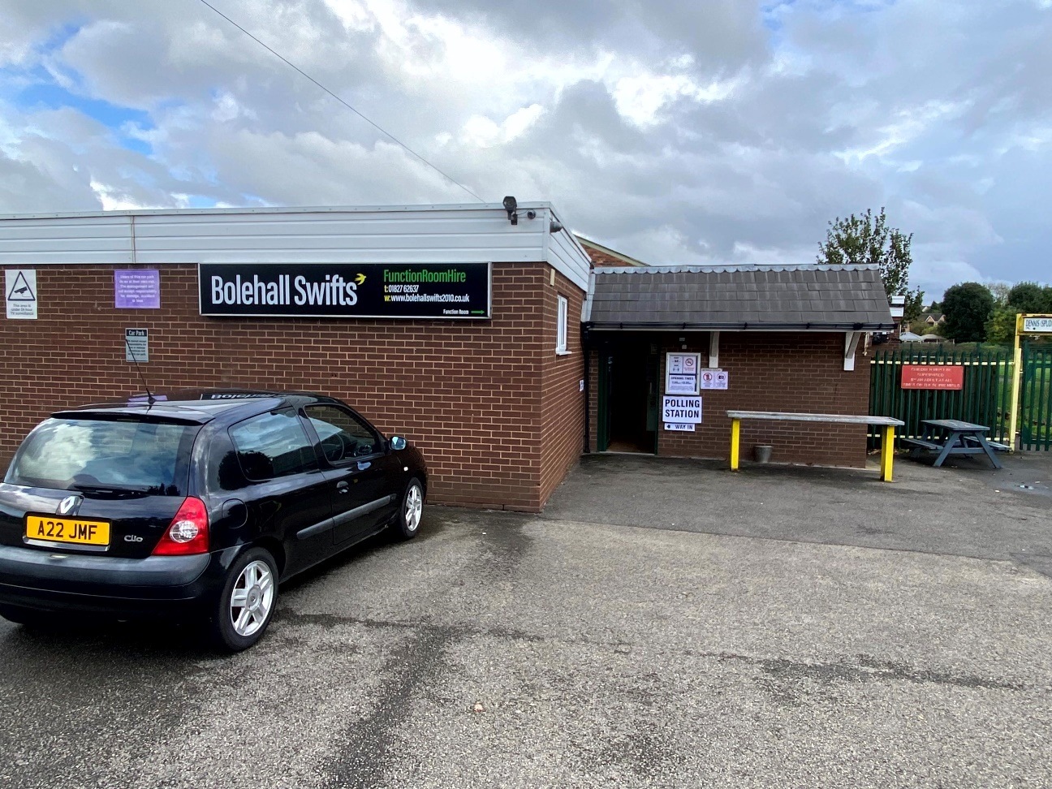
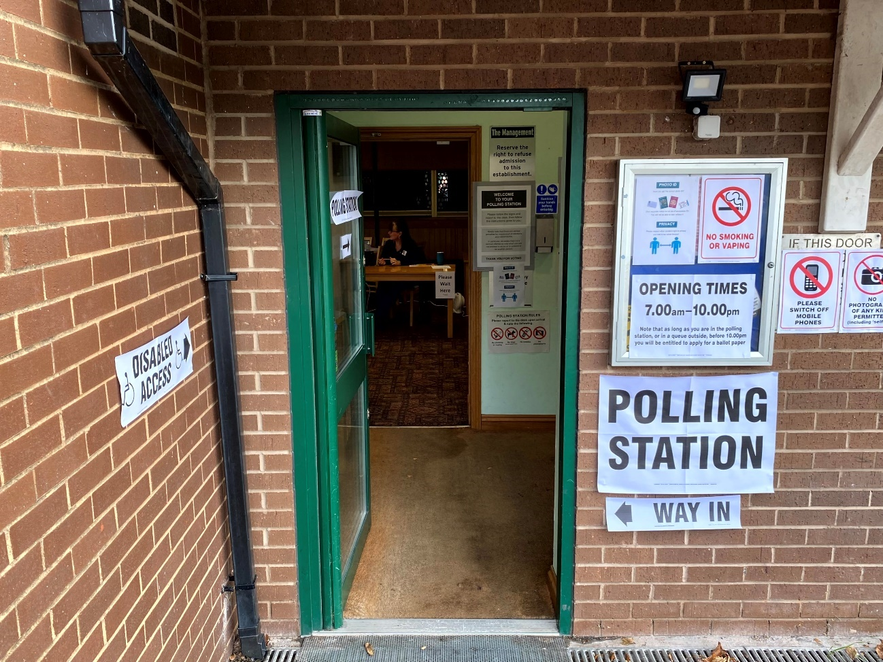

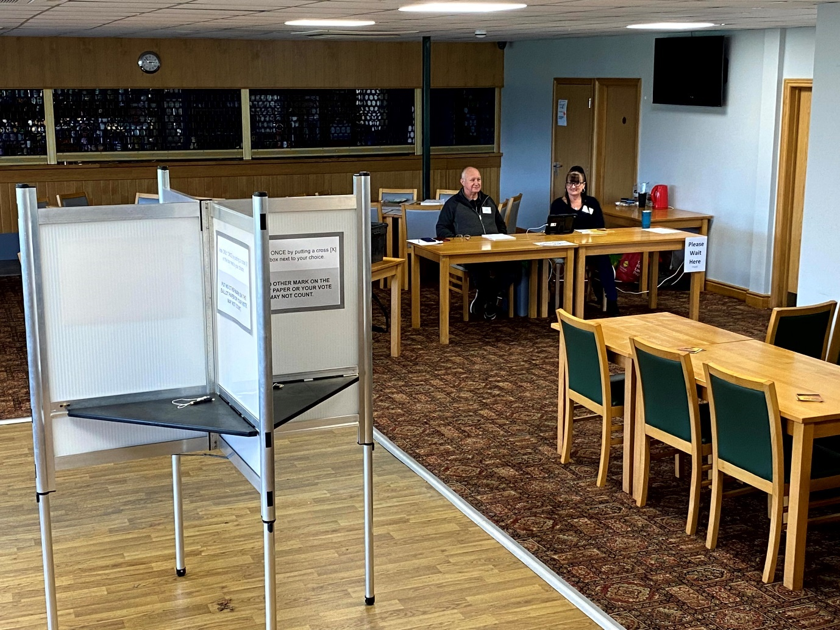

BO2 – William Macgregor Primary School

BO3 – Glascote Meeting Rooms
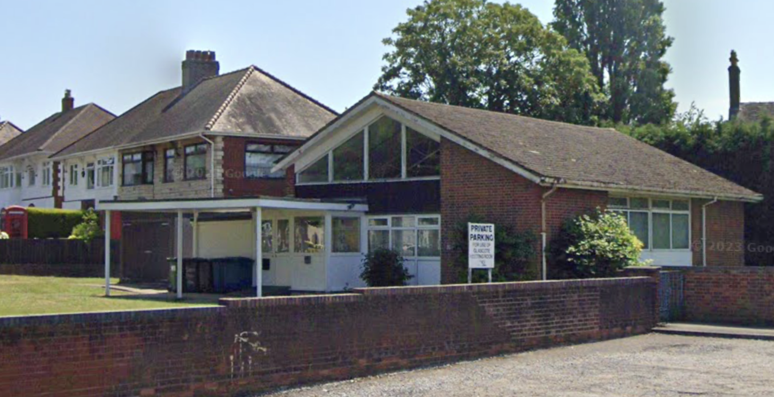

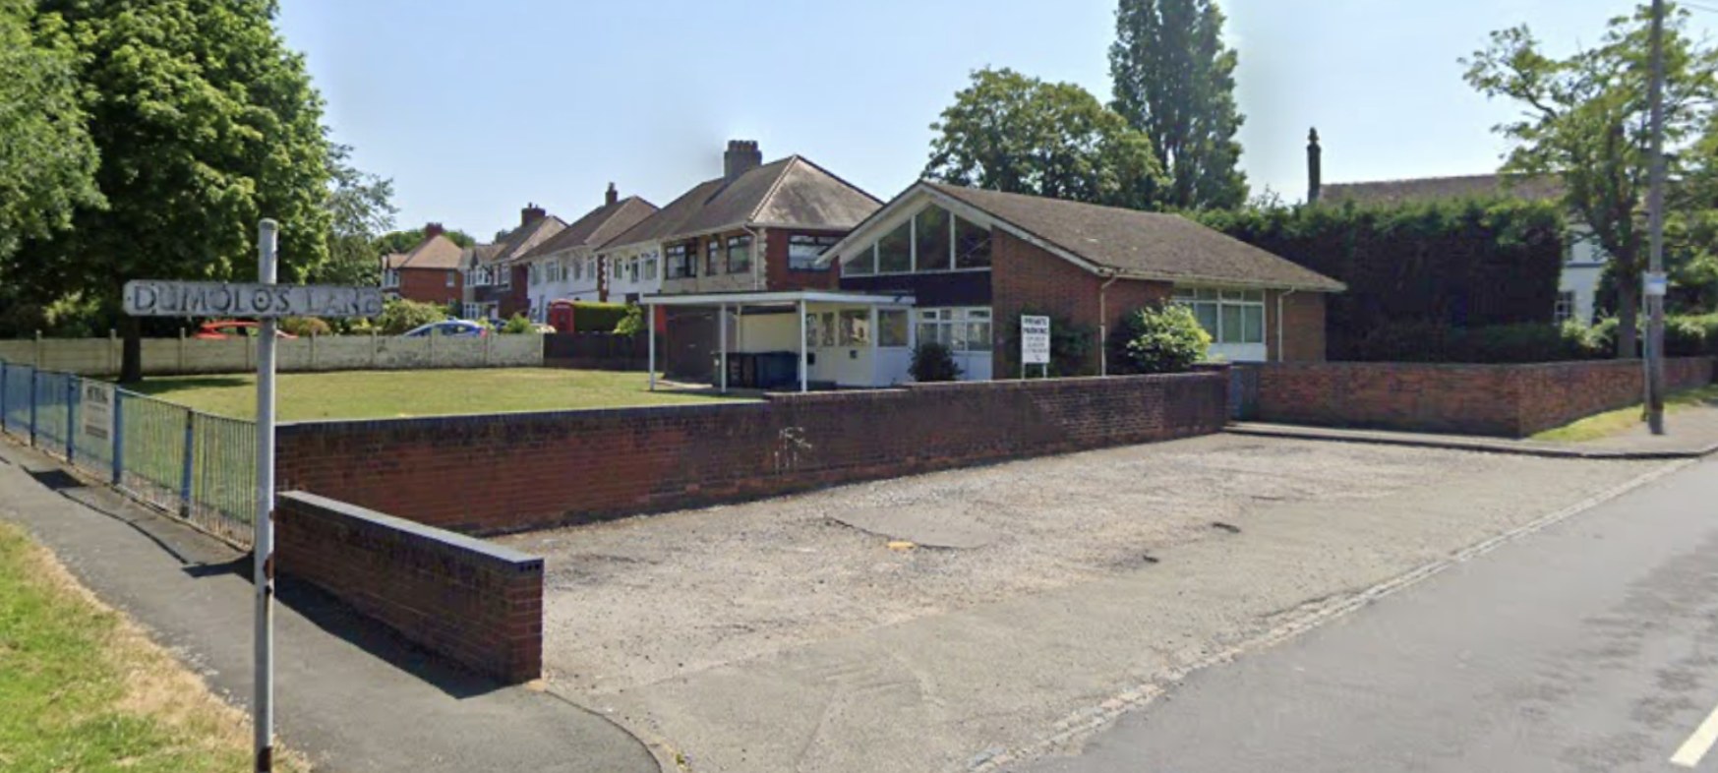

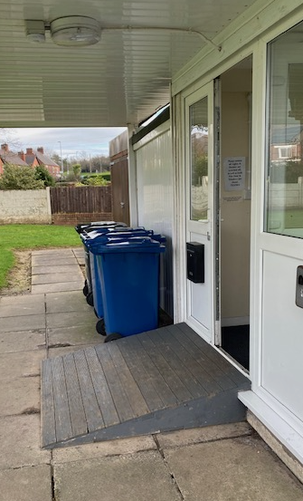

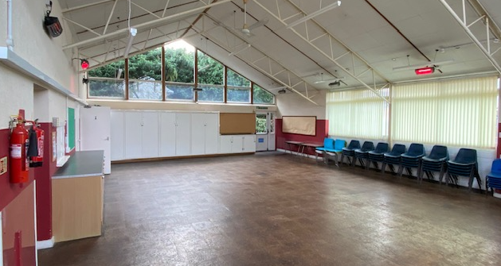

BO4 – Woodlands Primary School

