Castle Ward

Existing Polling Districts

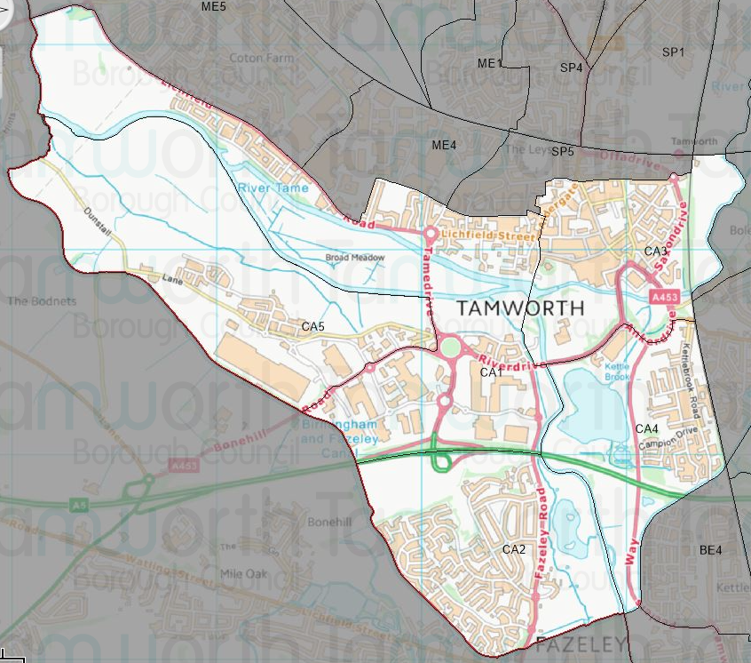

Existing Polling Stations
Polling District | Polling Station | Electorate | Polling Station Electorate | Disabled Access | What3Words Reference
CA1 | Sunset Close Community Centre | 1,749 | 1,368 | Yes | ///client.voice.smoke
CA2 | The Green (Durham Close) – Temporary Station | 2,093 | 1,686 | Yes | ///washed.pace.chase
CA3 | Community Meeting Room, St John’s RC Church | 964 | 795 | Yes | ///haven.mime.heats
CA4 | Sea Cadet Centre | 892 | 740 | Yes | ///flags.names.cling
CA5 | Sunset Close Community Centre | 1,172 | 1,063 | Yes | ///client.voice.smoke

Proposed Changes

Polling District | Polling Station | Recommendations
CA1 | Sunset Close Community Centre | No changes.
CA2 | The Green (Durham Close) – Temporary Station | No changes.
CA3 | Community Meeting Room, St John’s RC Church | No changes.
CA4 | Sea Cadet Centre | No changes.
CA5 | Sunset Close Community Centre | Change.

No negative comments or complaints have been received regarding the polling districts or polling stations at recent elections.

The only change proposed is to look at the possibility of using the newly built Dunstall Farm Primary Academy for the CA5 polling district.

No changes are proposed for any of the other polling districts and polling places as no negative comments or complaints have been received.

Castle Ward Polling Stations

CA1 & CA5 – Sunset Close Community Centre
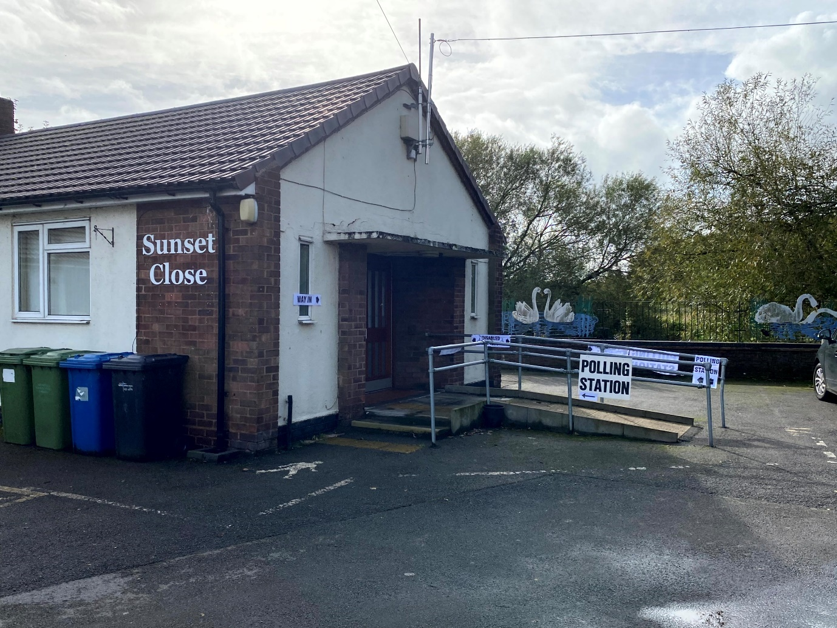

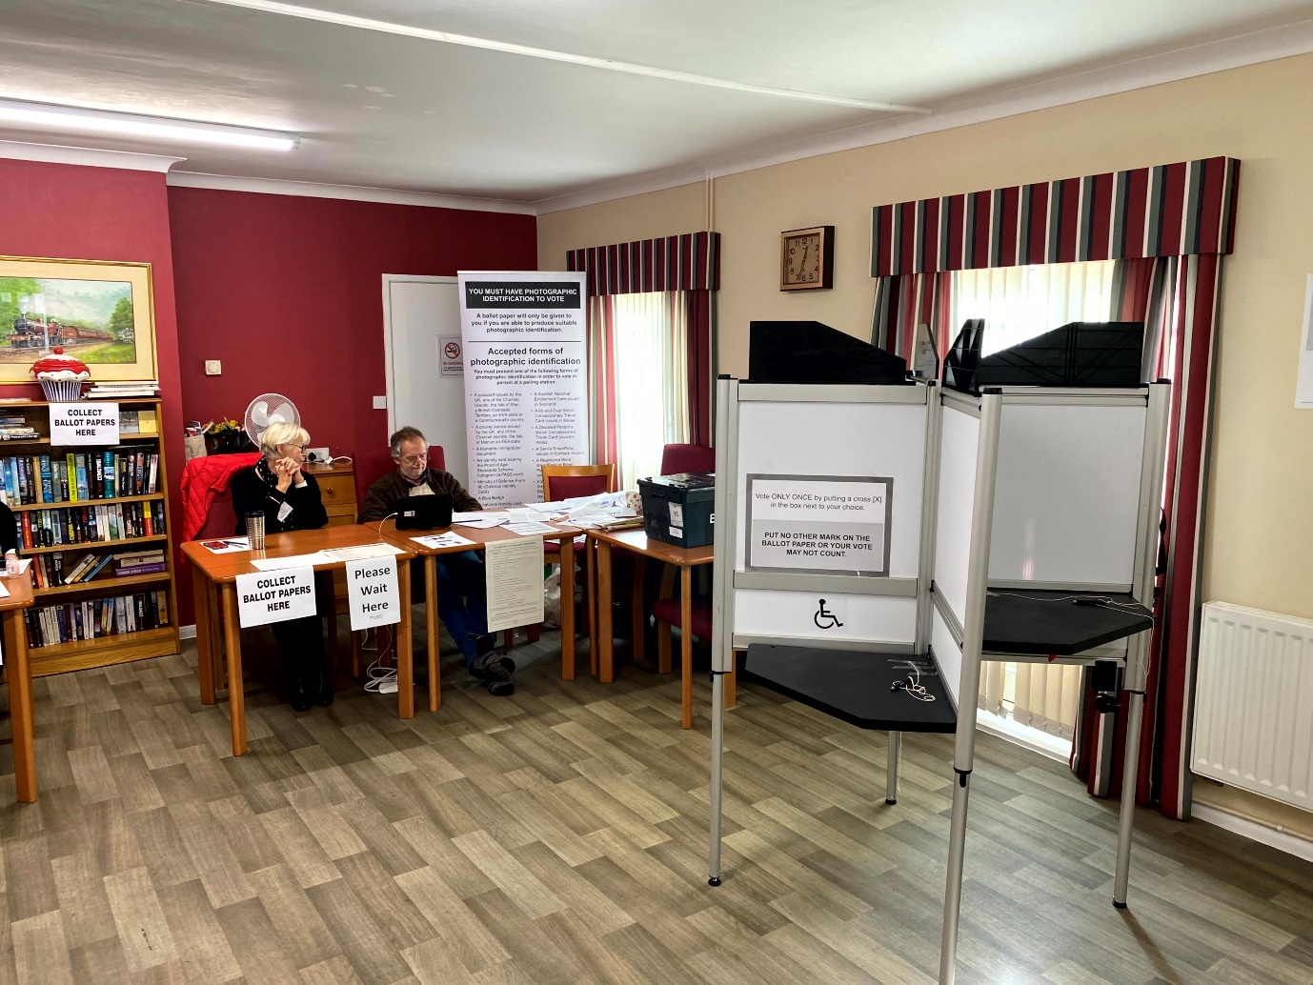

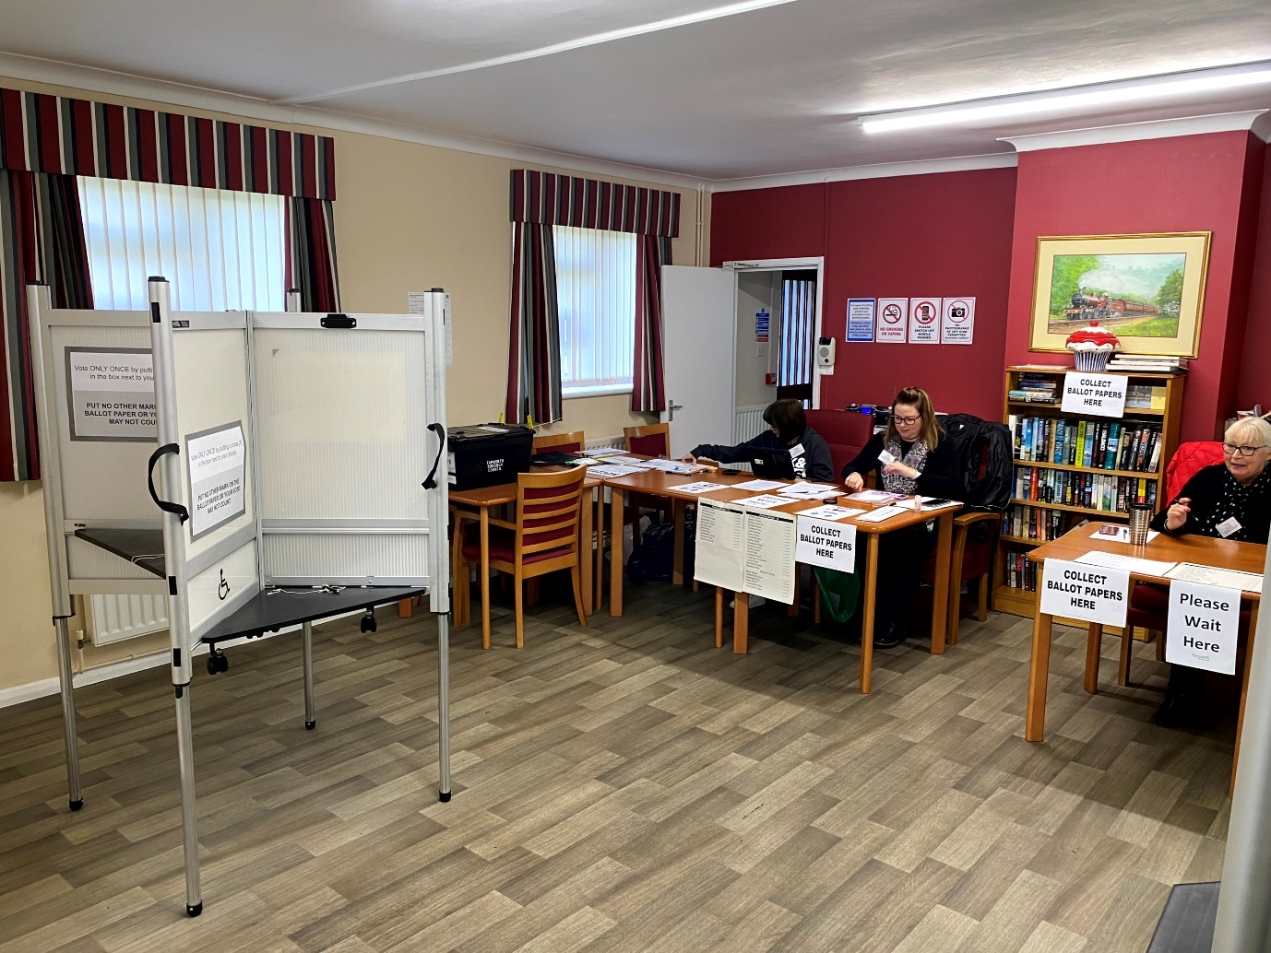

CA2 – The Green (Durham Close) Temporary Station

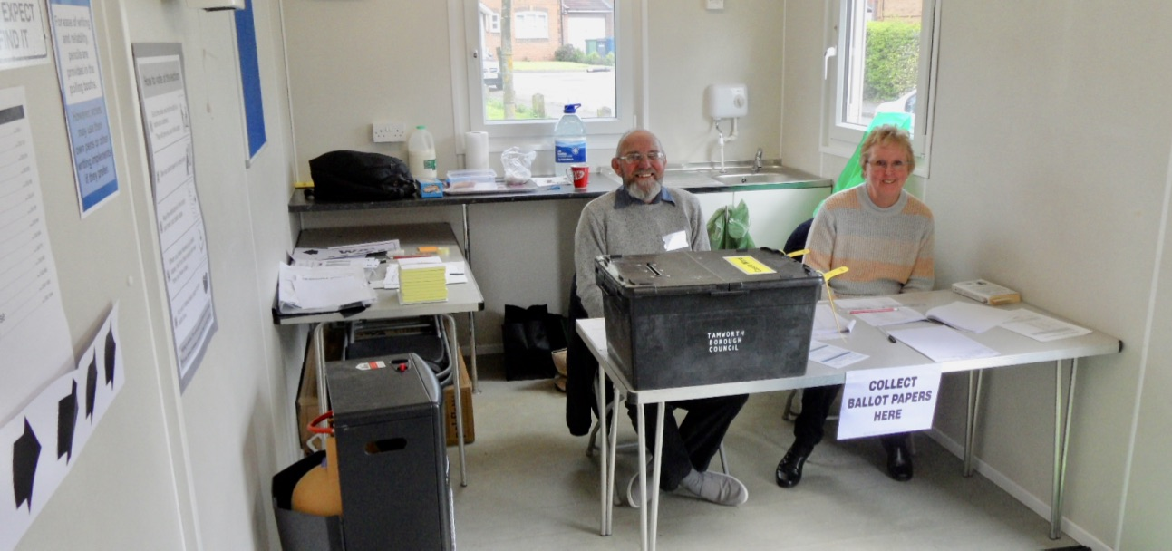

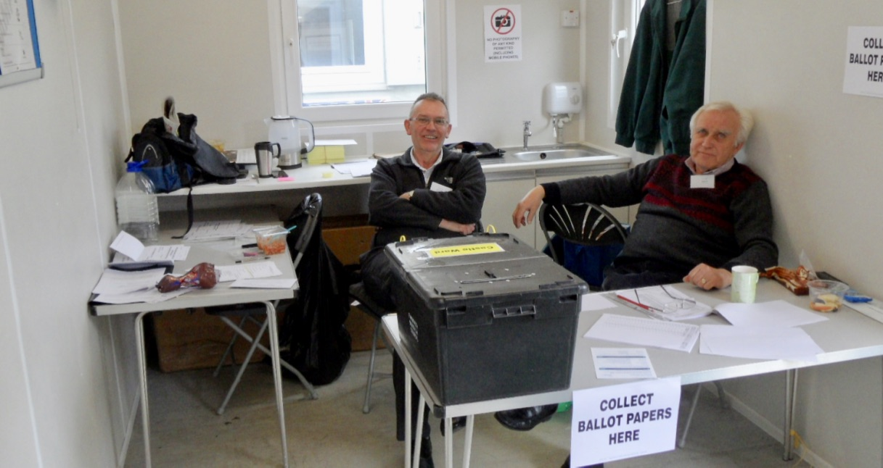

CA3 – Community Meeting Rooms, St John’s RC Church
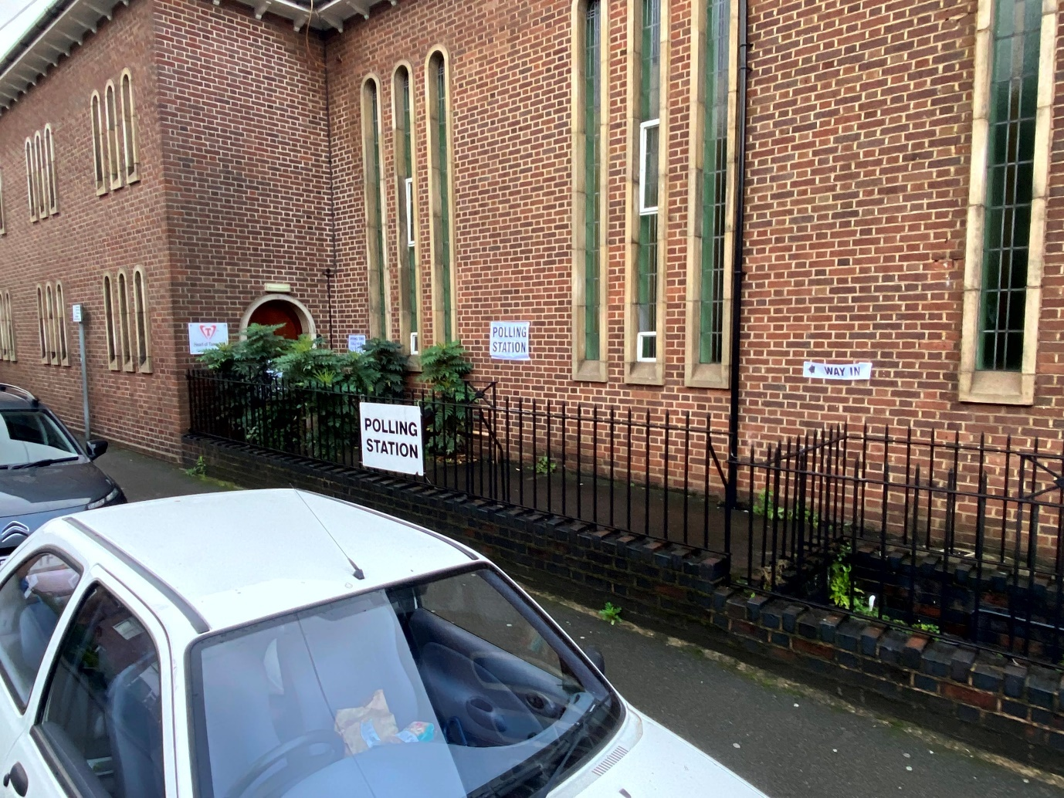

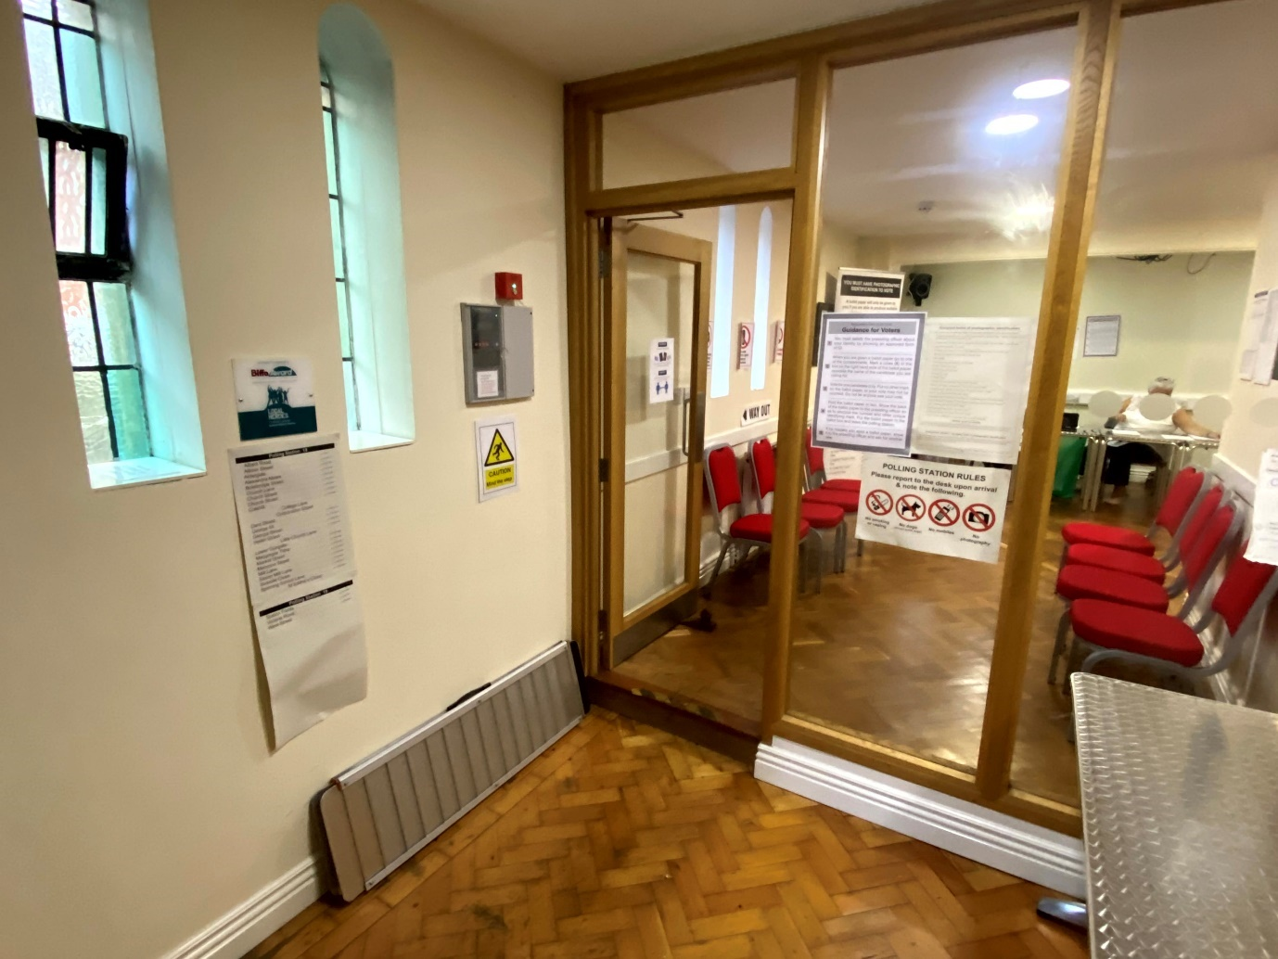

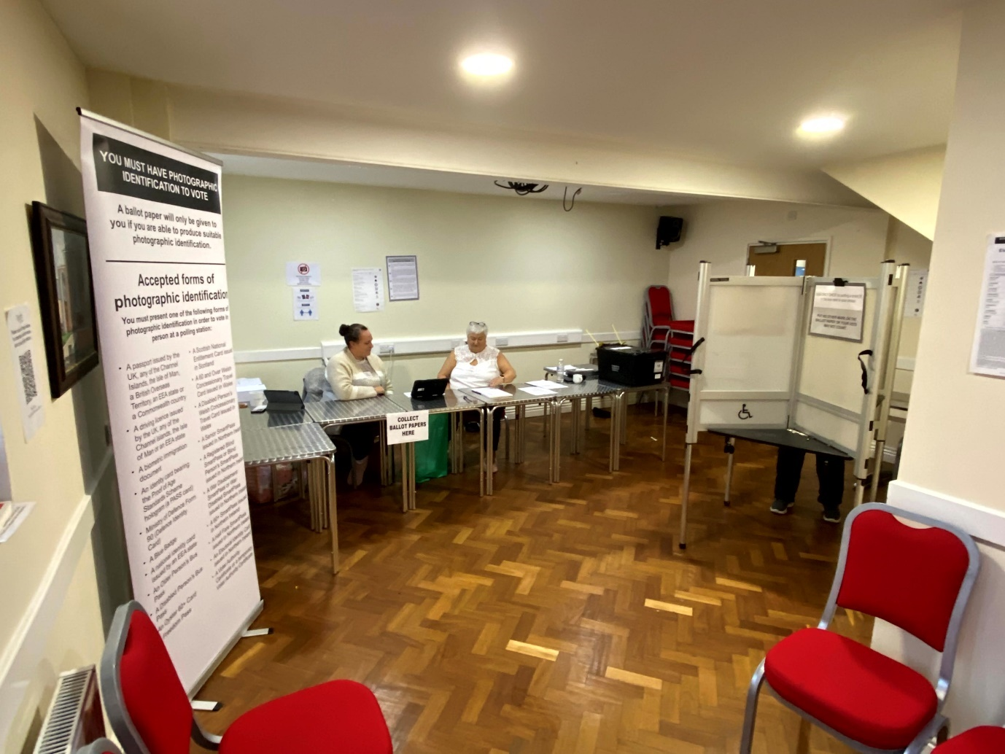

CA4 – Sea Cadet Centre
