**Glascote Ward**

**Existing Polling Districts**

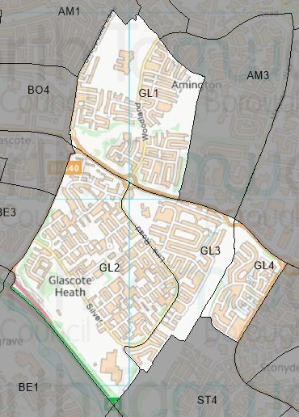

**Existing Polling Stations**

|  |  |  |  |  |  |
| --- | --- | --- | --- | --- | --- |
| *Polling District* | *Polling Station* | *Electorate* | *Polling Station Electorate* | *Disabled Access* | *What3Words Reference* |
| **GL1** | Sacred Heart Catholic Church | 1,515 | 1,189 | Yes | ///cans.refers.cross |
| **GL2** | Oakhill Primary School | 2,425 | 2,132 | Yes | ///turned.remove.will |
| **GL3** | Sacred Heart Catholic Church | 937 | 743 | Yes | ///cans.refers.cross |
| **GL4** | Stoneydelph Primary School | 609 | 547 | Yes | ///smiled.stack.lands |

**Proposed Changes**

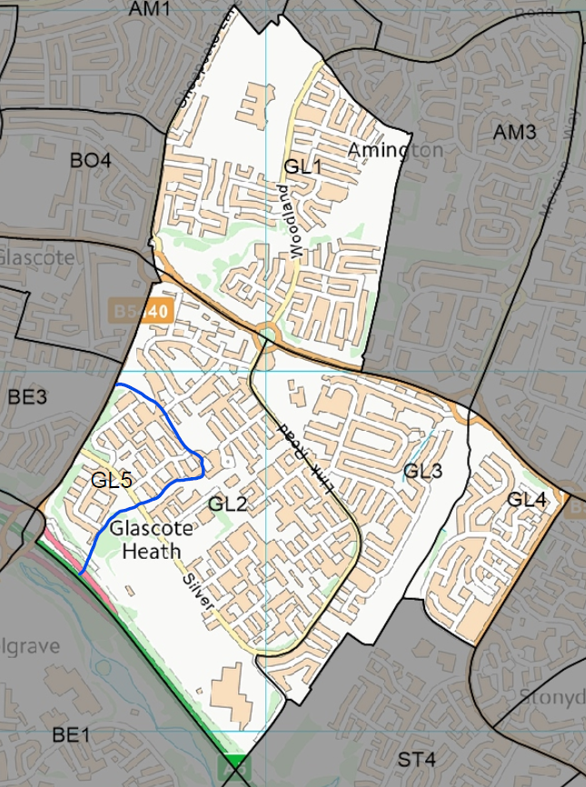

| *Polling District* | *Polling Station* | *Recommendations* |
| --- | --- | --- |
| GL1 | Sacred Heart Catholic Church | No change. |
| GL2 | Oakhill Primary School | Change.  Amend polling district boundary to create a new polling district to be known as GL5. |
| GL3 | Sacred Heart Catholic Church | No change. |
| GL4 | Stoneydelph Primary School | No change. |
| GL5 | Oakhill Primary School | Creation.  Creation of a new polling district to ensure that any combination of elections can be run successfully. |

No negative comments or complaints have been received regarding the polling stations at recent elections. Therefore, no changes are proposed to these.

However, due to County Council boundary changes the creation of a new polling district is required to ensure that next year’s County Council election can be run successfully and to allow for different types of election to be run on the same day. This new polling district will be called GL5 and will be made up of properties from the following streets that were originally in GL2:

* Ivatt
* Maitland
* Kirtley

The remaining polling districts will remain unchanged.

Glascote Ward Polling Stations

GL1 & GL3 – Sacred Heart RC Church

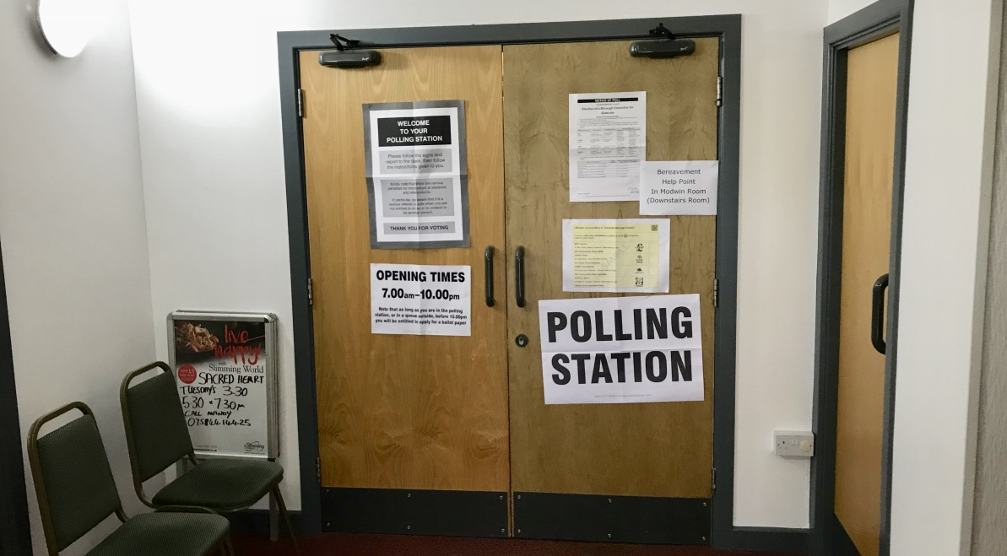

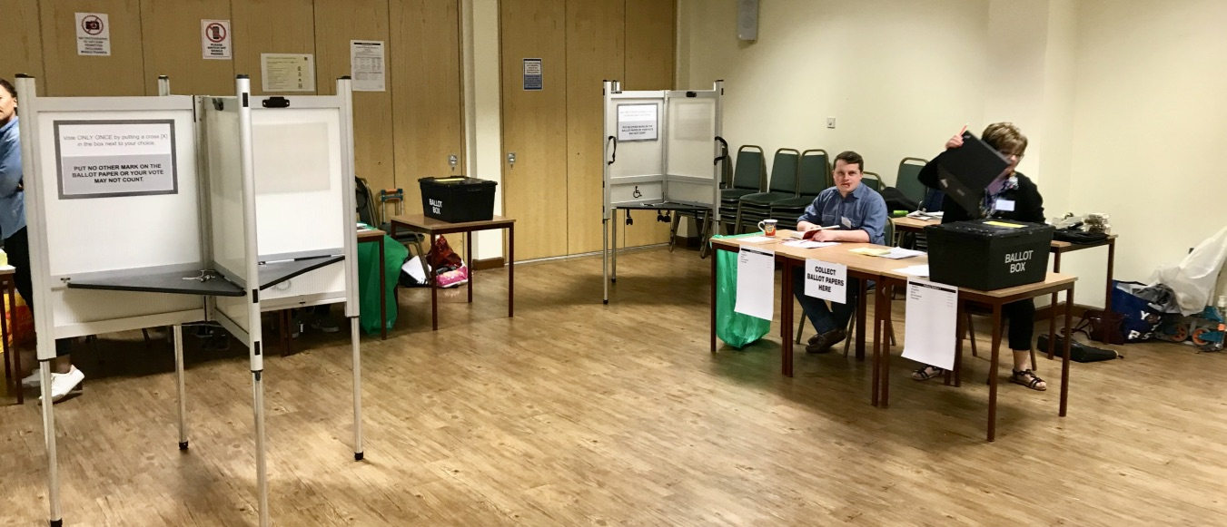

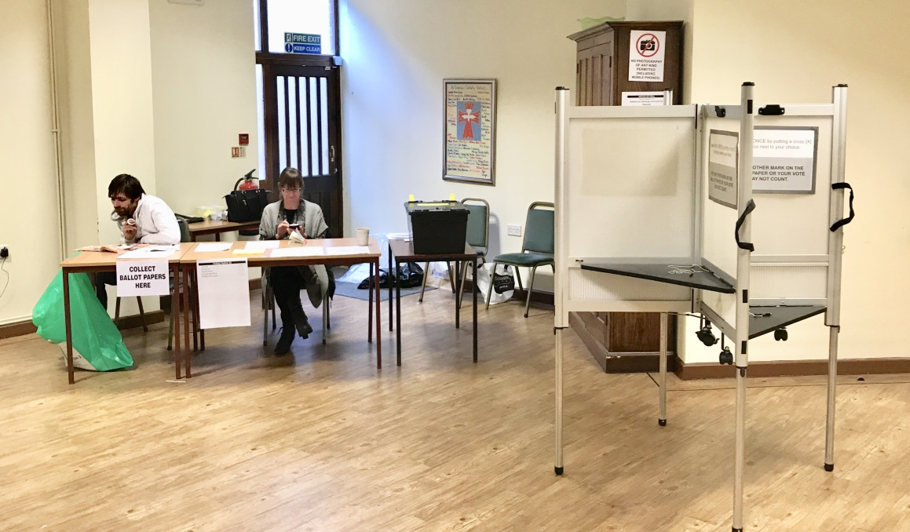

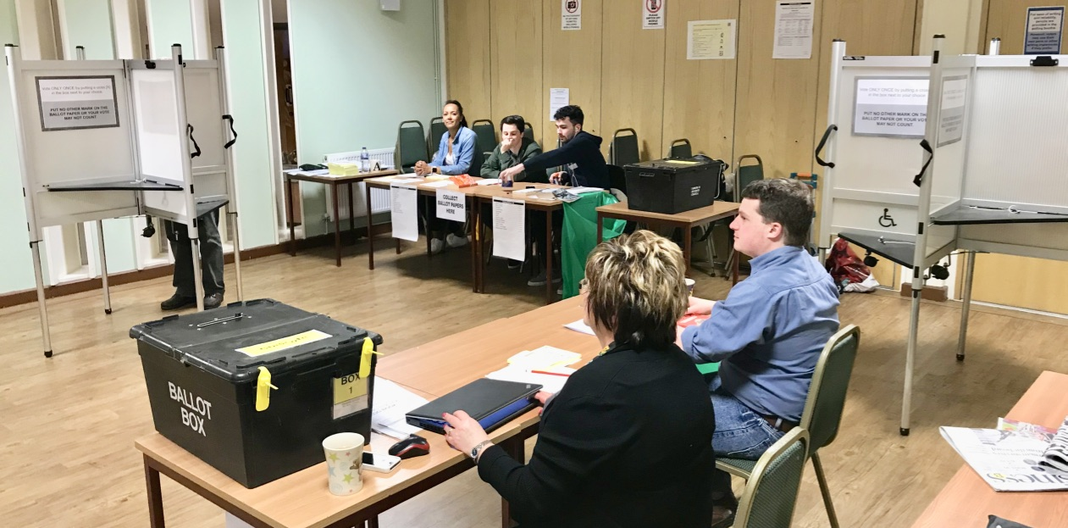

GL2 – Oakhill Primary School

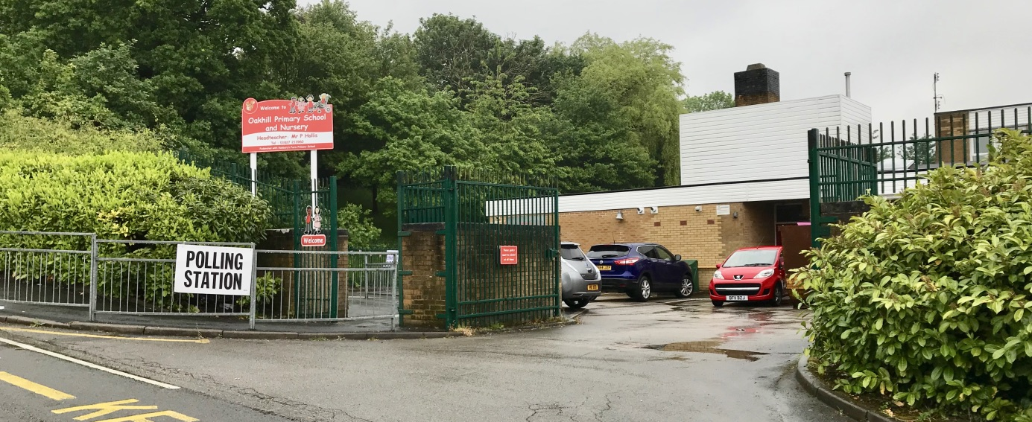

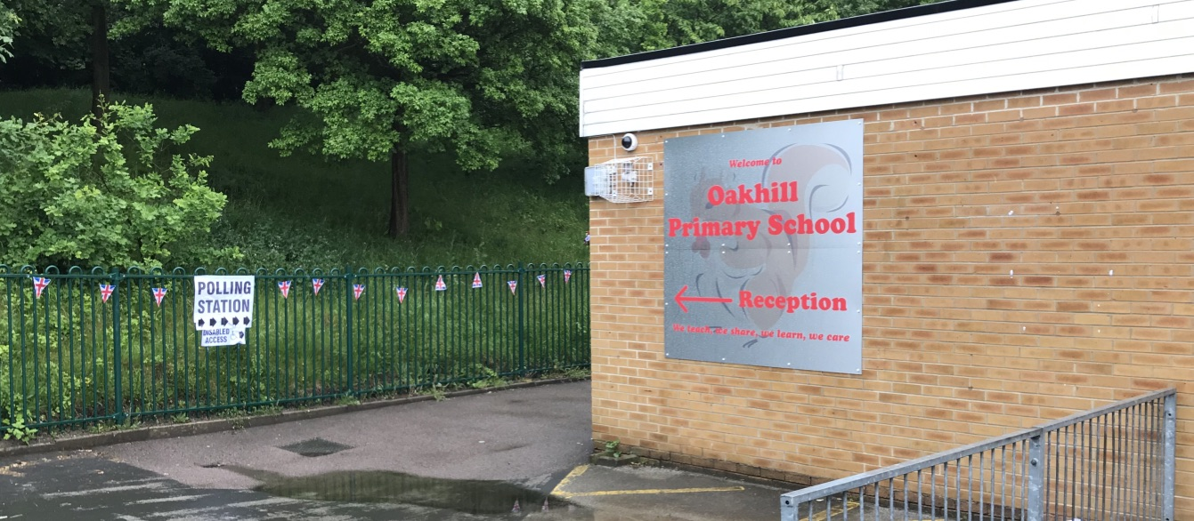

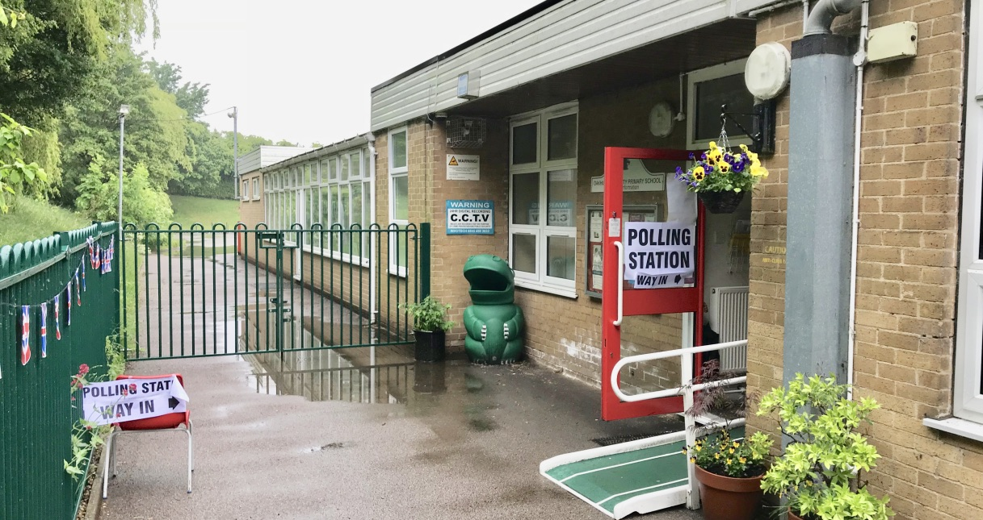

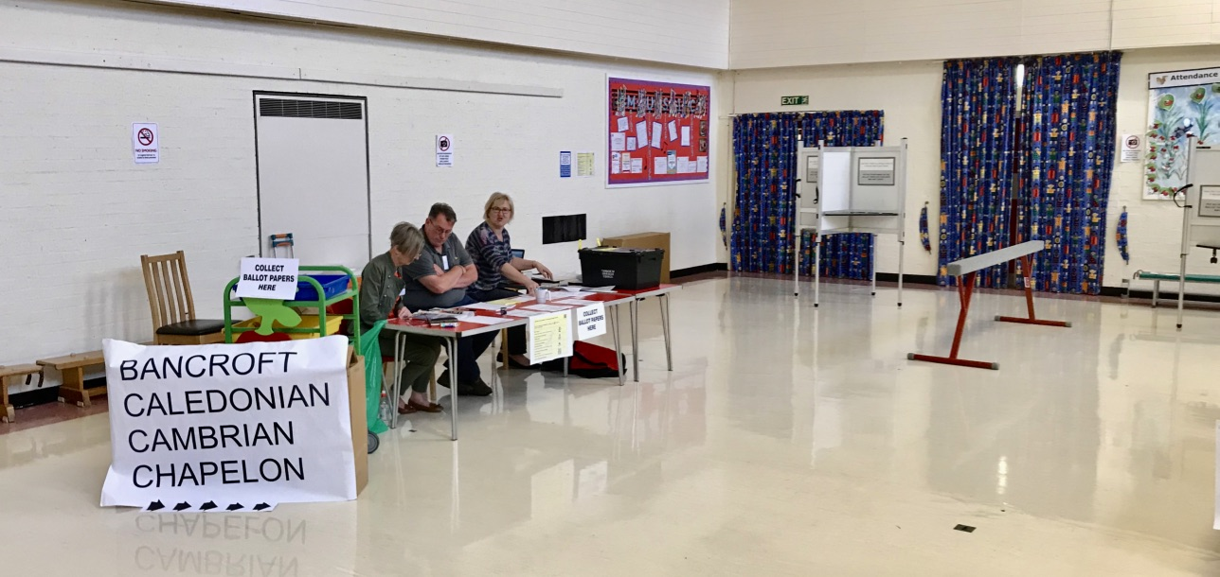

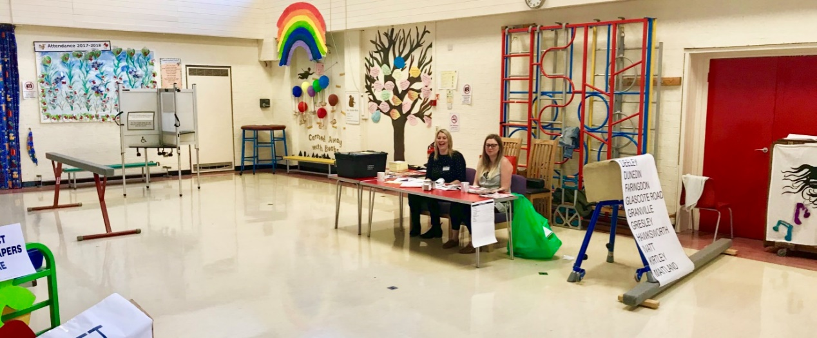

GL4 – Stoneydelph Primary School

