Spital Ward

Existing Polling Districts

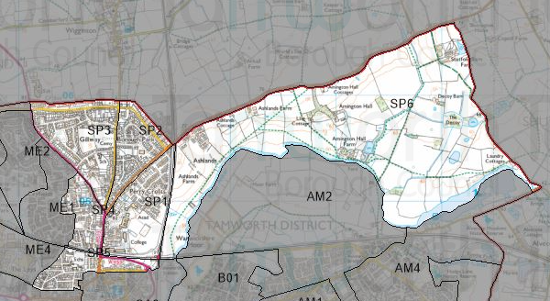

Existing Polling Stations
Polling District | Polling Station | Electorate | Polling Station Electorate | Disabled Access | What3Words Reference
SP1 | School Canteen – Landau Forte QEMS | 948 | 674 | Yes | ///sung.pound.composers
SP2 | Ashcroft Infants and Nursery School | 1,101 | 865 | Yes | ///whites.view.trains
SP3 | Flax Hill Junior Academy | 1,524 | 1,228 | Yes | ///bossy.zeal.economies
SP4 | St Andrew’s Methodist Church Hall | 792 | 608 | Yes | ///ranges.verge.thinks
SP5 | Moorgate Primary Academy | 1,043 | 838 | Yes | ///cracks.grades.swept
SP6 | Anker Valley Primary Academy | 1,064 | 940 | Yes | ///bared.cling.hops

Proposed Changes

Polling District | Polling Station | Recommendations
SP1 | School Canteen – Landau Forte QEMS | No change.
SP2 | Ashcroft Infants and Nursery School | No change.
SP3 | Flax Hill Junior Academy | No change.
SP4 | St Andrew’s Methodist Church Hall | No change.
SP5 | Moorgate Primary Academy | No change.
SP6 | Anker Valley Primary Academy | No change.

No negative comments or complaints have been received regarding the polling districts or polling stations at recent elections. Therefore, no changes are proposed.

Spital Ward Polling Stations

SP1 – School Canteen, Landau Forte QEMS

SP2 – Ashcrofts Infants & Nursery School

SP3 – Flax Hill Junior Academy





SP4 – St Andrew’s Methodist Church Hall

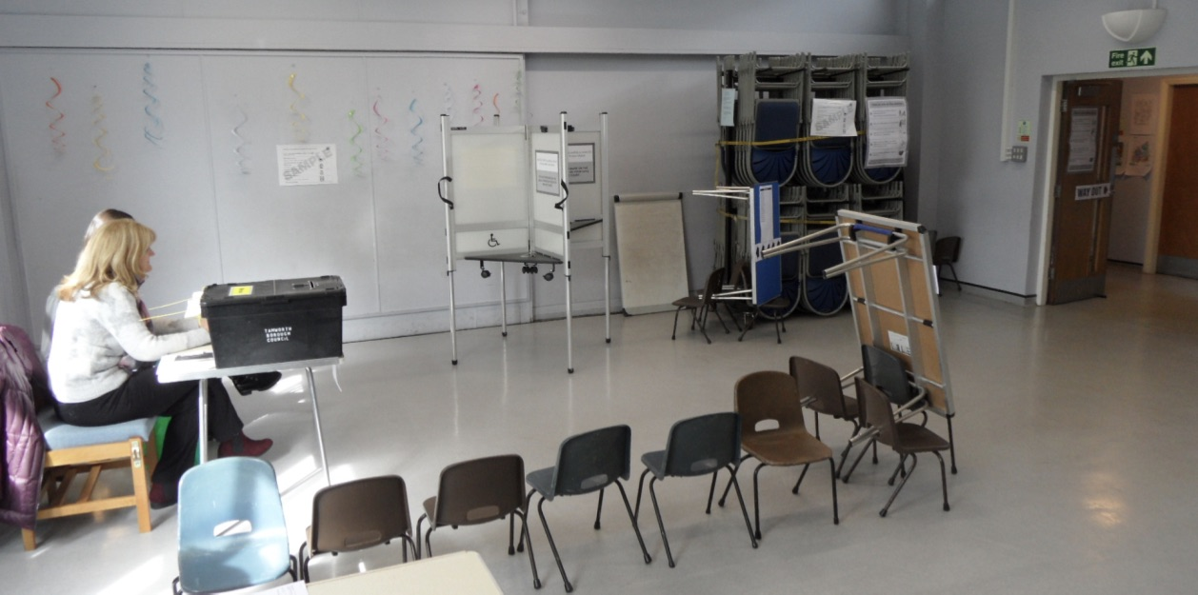

SP5 – Moorgate Primary Academy

SP6 – Anker Valley Primary Academy

