**Stonydelph Ward**

**Existing Polling Districts**

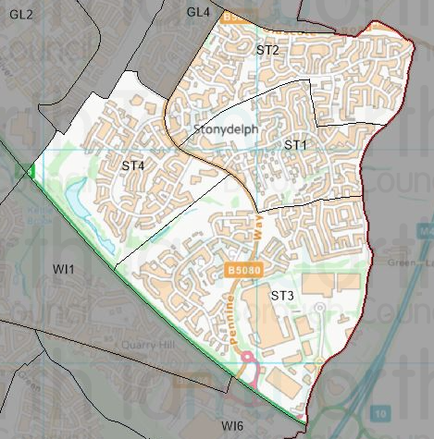

**Existing Polling Stations**

|  |  |  |  |  |  |
| --- | --- | --- | --- | --- | --- |
| *Polling District* | *Polling Station* | *Electorate* | *Polling Station Electorate* | *Disabled Access* | *What3Words Reference* |
| ST1 | Pennymoor Community Hall | 1,271 | 1,029 | Yes | ///civil.bikes.gravy |
| ST2 | St Martin in the Delph Community Centre | 1,675 | 1,352 | Yes | ///media.goods.cheek |
| ST3 | Pennymoor Community Hall | 1,568 | 1,251 | Yes | ///civil.bikes.gravy |
| ST4 | Stoneydelph Primary School | 1,100 | 927 | Yes | ///smiled.stack.lands |

**Proposed Changes**



| *Polling District* | *Polling Station* | *Recommendations* |
| --- | --- | --- |
| ST1 | Pennymoor Community Hall | No change. |
| ST2 | St Martin in the Delph Community Centre | No change. |
| ST3 | Pennymoor Community Hall | No change. |
| ST4 | Stoneydelph Primary School | No change. |

No negative comments or complaints have been received regarding the polling districts or polling stations at recent elections. Therefore, no changes are proposed.

Stonydelph Ward Polling Stations

ST1 & ST3 - Pennymoor Community Centre

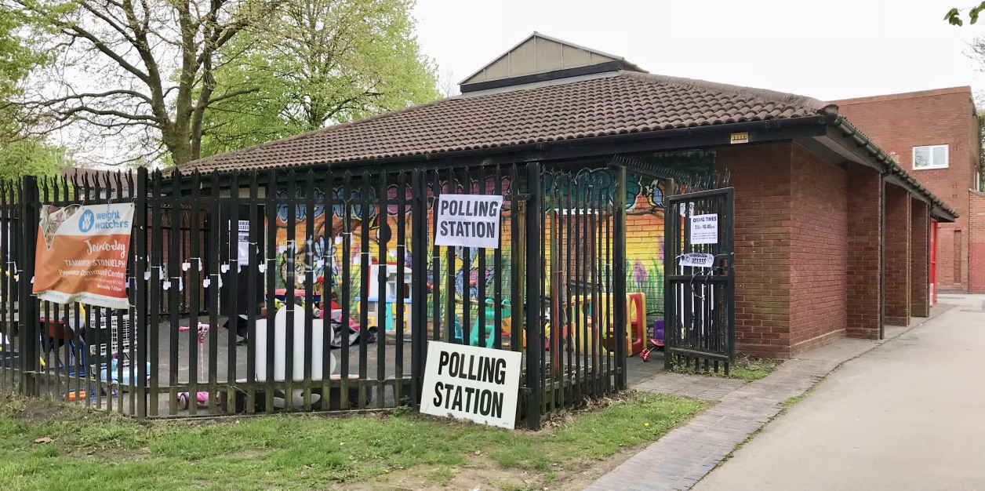

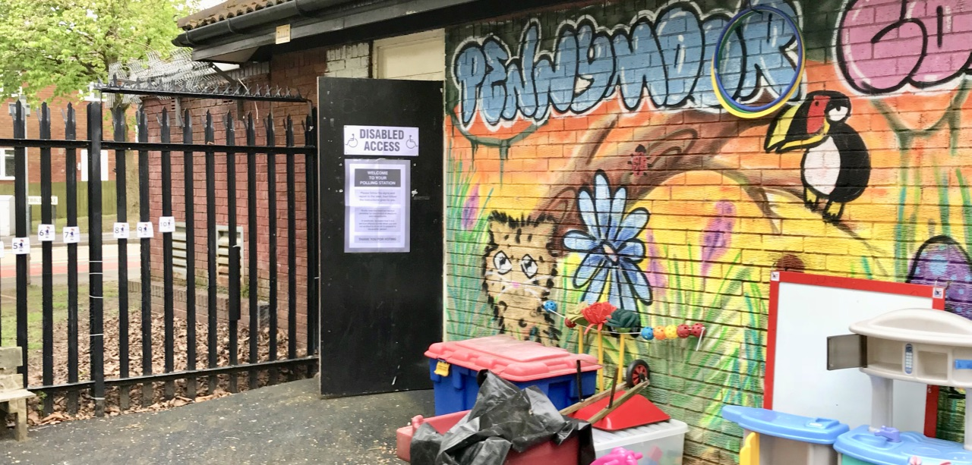

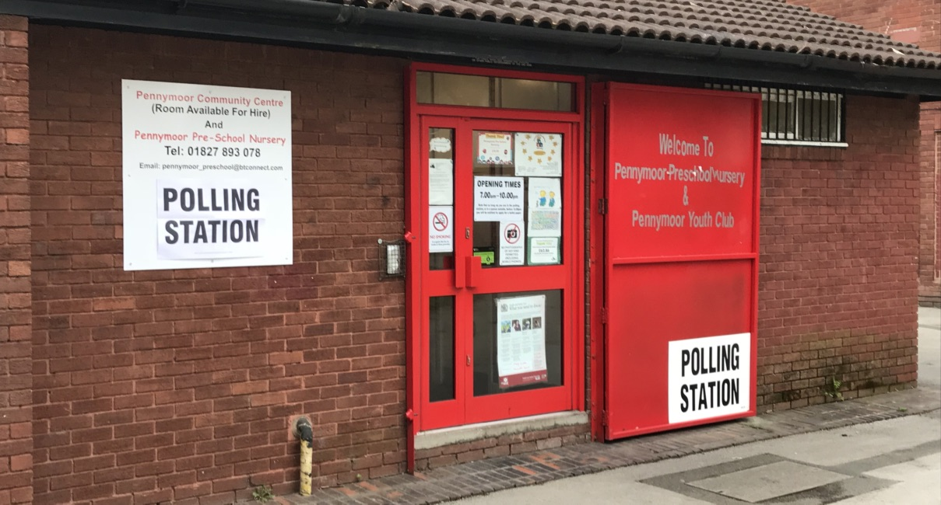

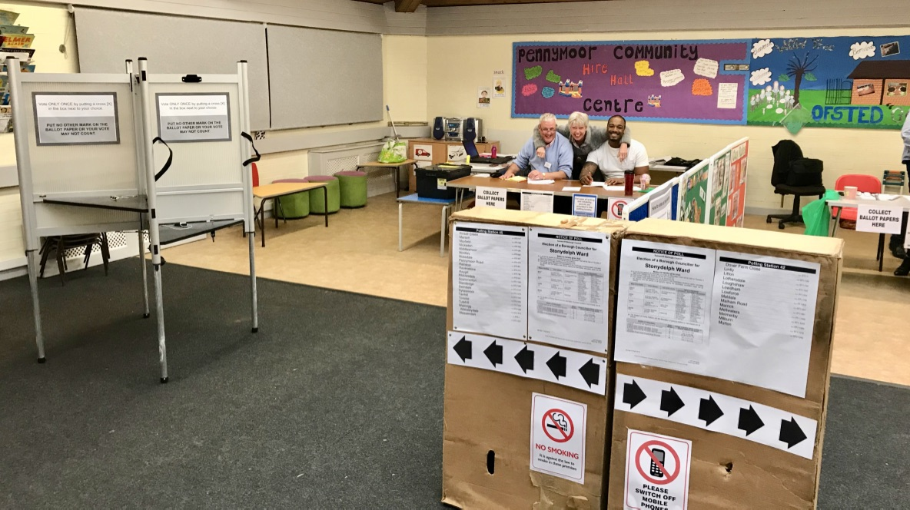

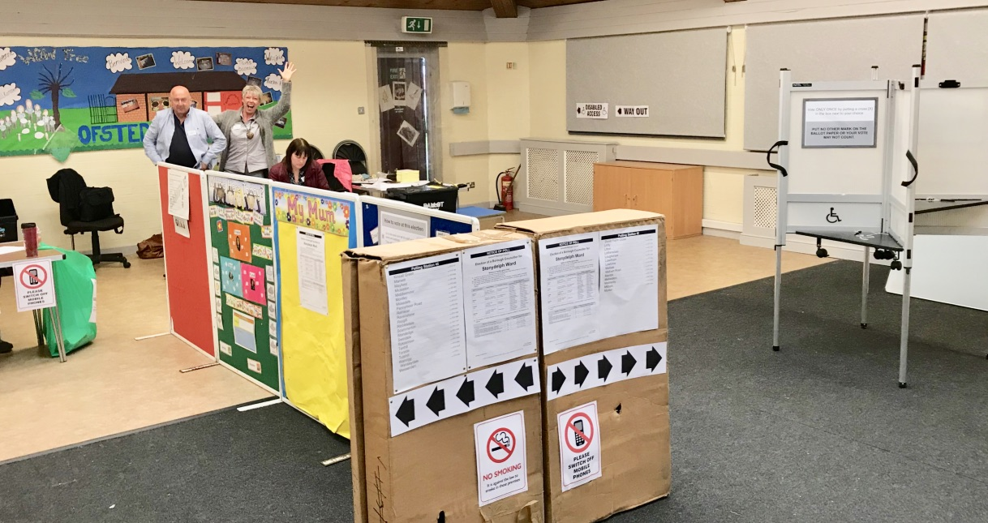

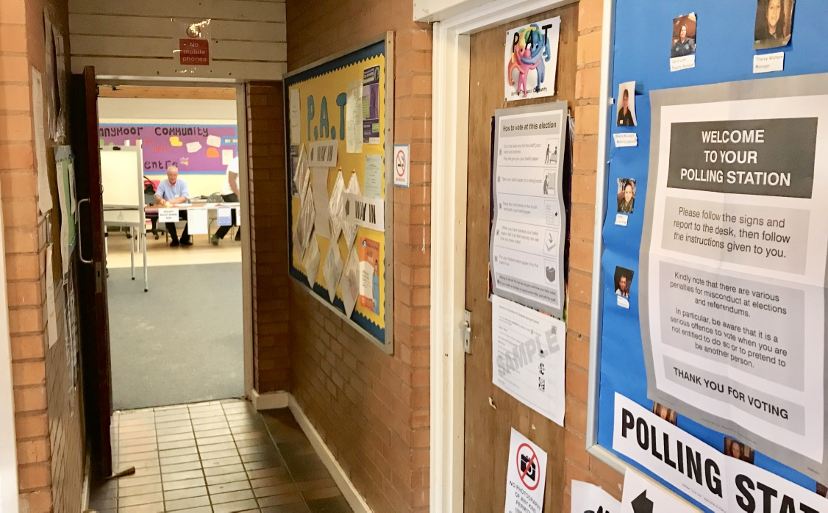

ST2 – St Martin in the Delph Community Centre

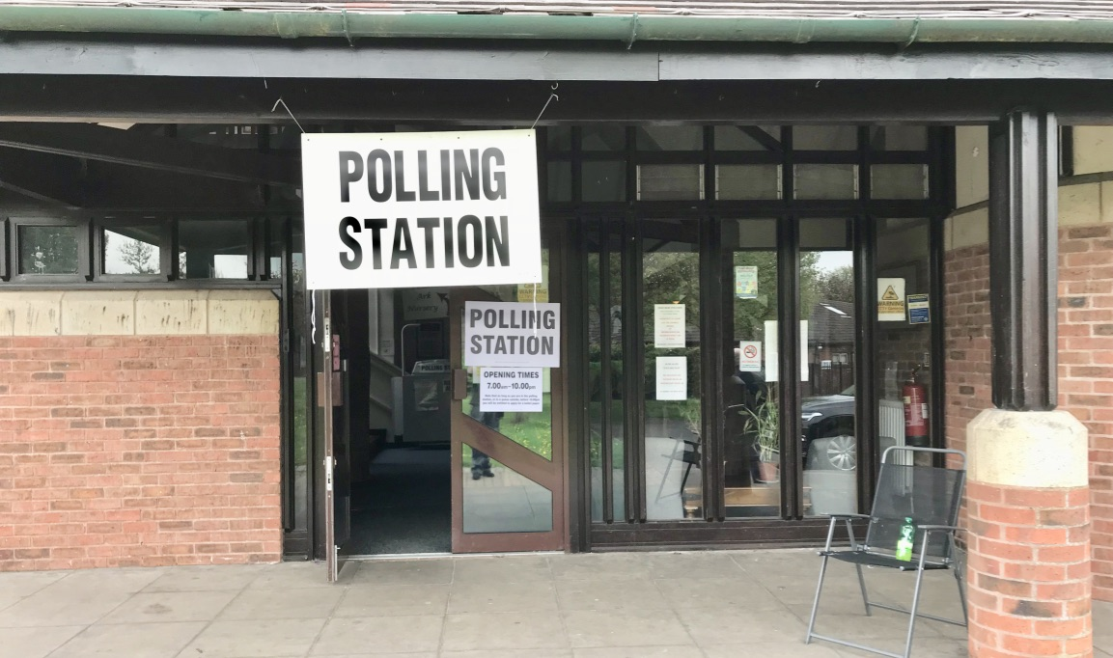

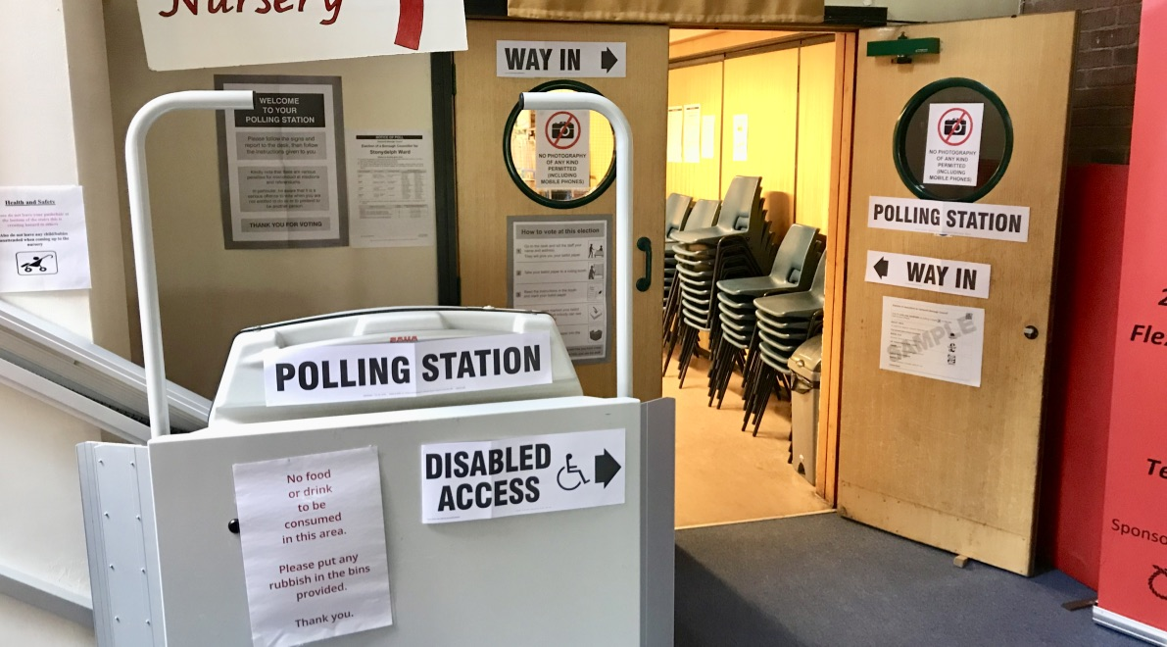

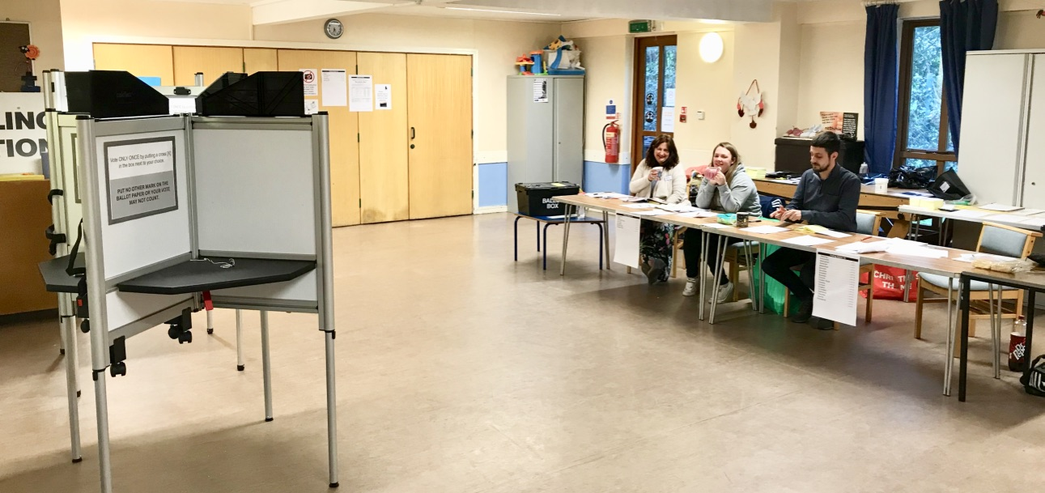

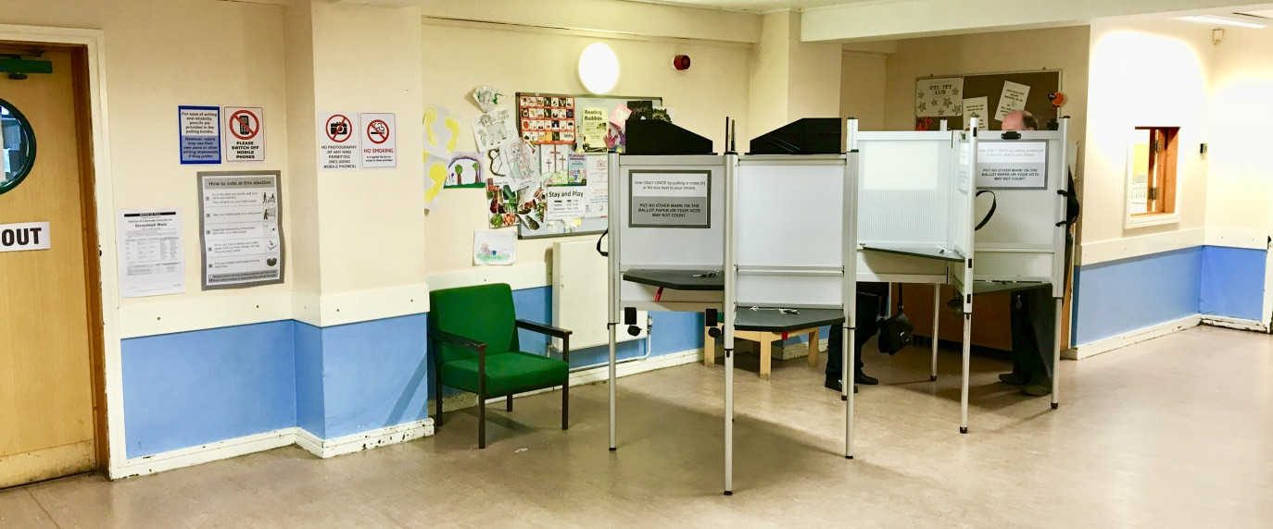

ST4 – Stoneydelph Primary School

