Trinity Ward

Existing Polling Districts

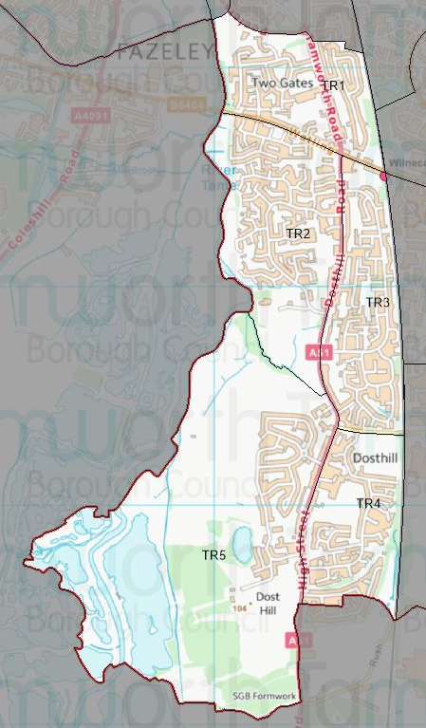

Existing Polling Stations
Polling District | Polling Station | Electorate | Polling Station Electorate | Disabled Access | What3Words Reference
TR1 | Two Gates Primary School | 1275 | 1076 | Yes | ///cheek.peanut.slows
TR2 | Dorcas Centre | 1234 | 973 | Yes | ///mixed.lasts.tilt
TR3 | Dorado – Temporary Station | 1446 | 1198 | Yes | ///lately.cloud.pram
TR4 | Dosthill Boys Club | 1019 | 839 | Yes | ///owls.supper.smiles
TR5 | Dosthill Boys Club | 815 | 631 | Yes | ///owls.supper.smiles

Proposed Changes

Polling District | Polling Station | Recommendations
TR1 | Two Gates Primary School | No change.
TR2 | Dorcas Centre | No change.
TR3 | Dorado – Temporary Station | No change.
TR4 | Dosthill Boys Club | No change.
TR5 | Dosthill Boys Club | No change.

No negative comments or complaints have been received regarding the polling districts or polling stations at recent elections. Therefore, no changes are proposed.

Trinity Ward Polling Stations

TR1 – Two Gates Primary School

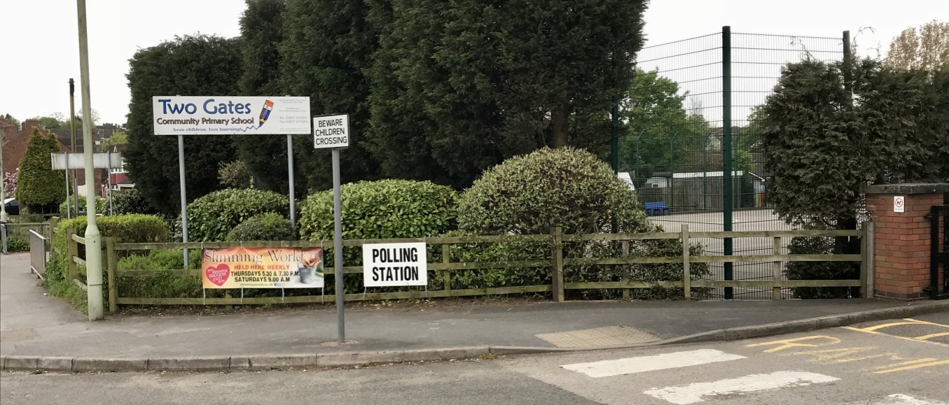

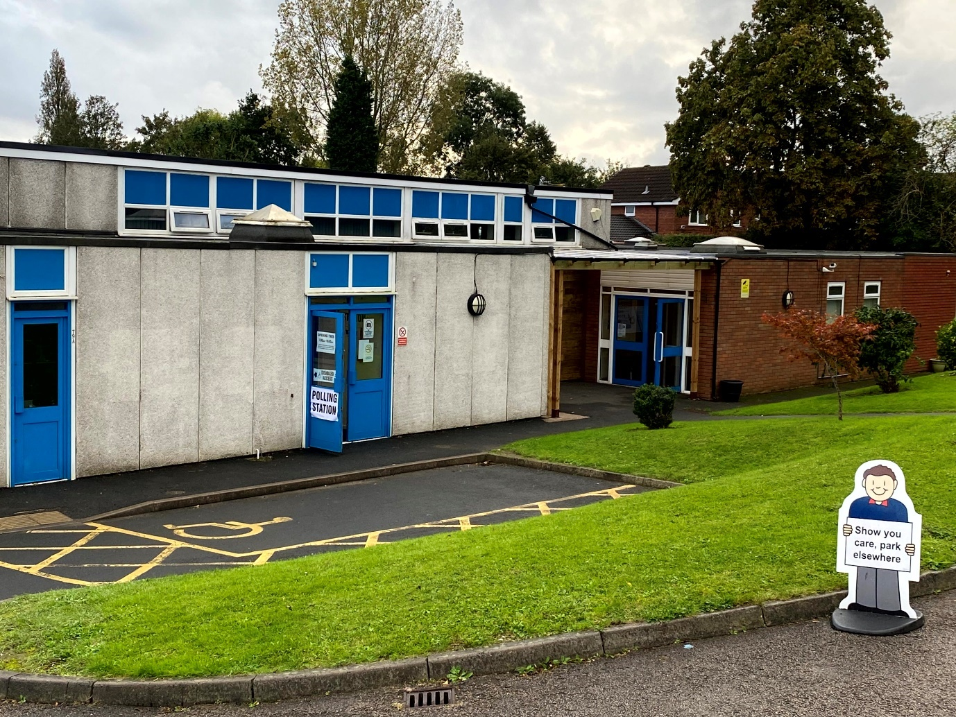

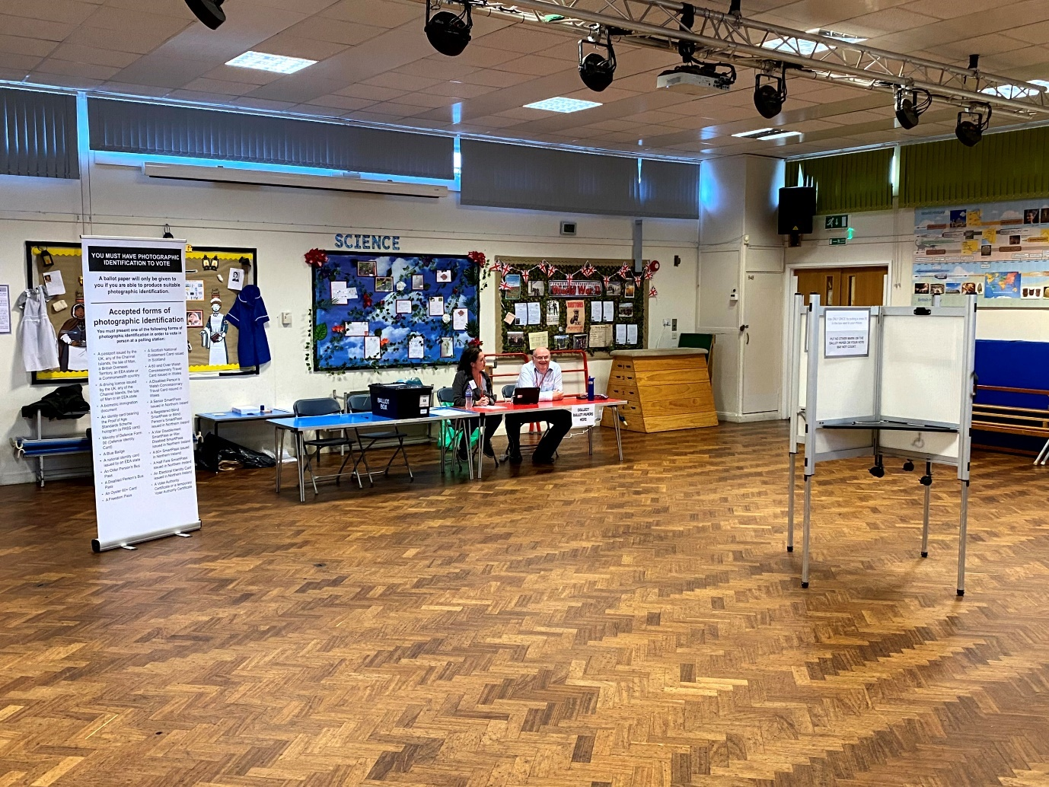

TR2 – Dorcas Centre

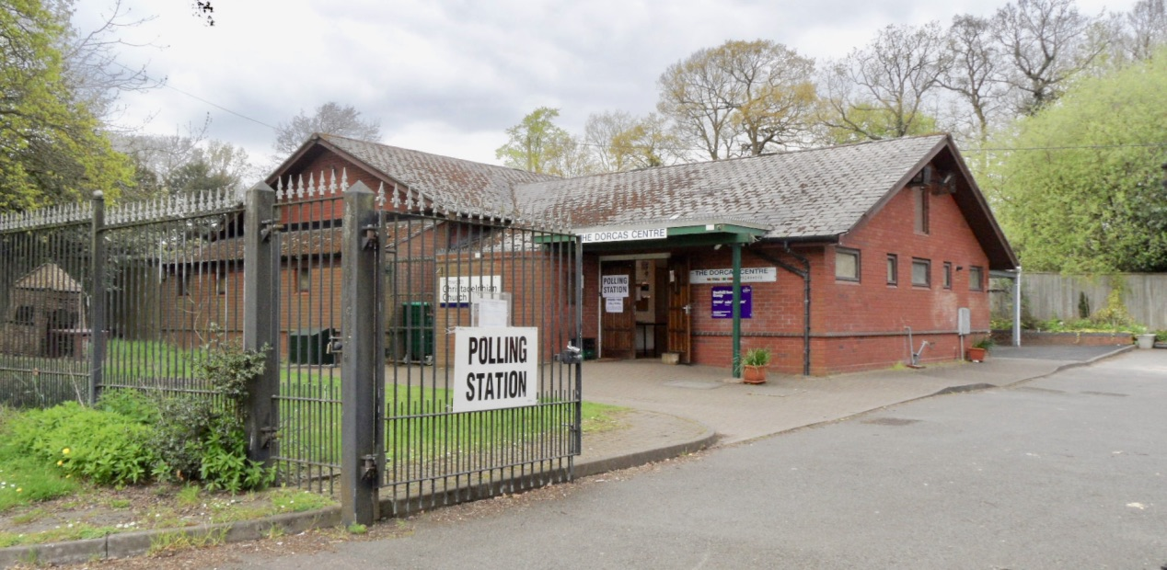

TR3 – Dorado – Temporary Station

TR4 & TR5 – Dosthill Boys Club

