Wilnecote Ward

Existing Polling Districts

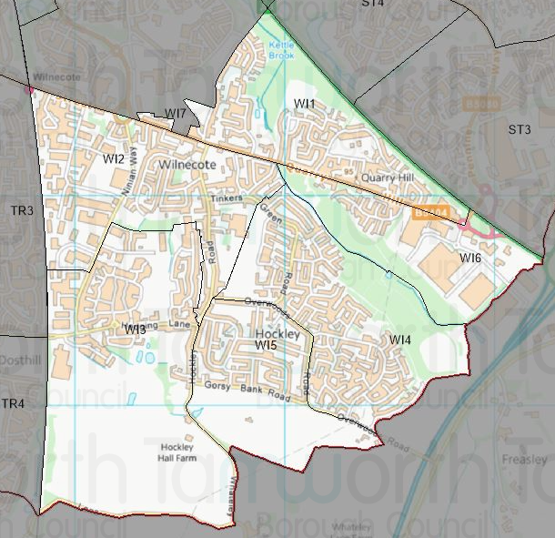

Existing Polling Stations
Polling District | Polling Station | Electorate | Polling Station Electorate | Disabled Access | What3Words Reference
WI1 | Wilnecote Junior Academy | 1,315 | 1,046 | Yes | ///desks.drift.public
WI2 | Wilnecote Junior Academy | 1,219 | 992 | Yes | ///desks.drift.public
WI3 | Palmerston Avenue – Temporary Station | 1,265 | 1,084 | Yes | ///boil.verbs.expose
WI4 | Heathfields Infants Academy | 1,841 | 1,442 | Yes | ///credit.coins.sounds
WI5 | Heathfields Infants Academy | 998 | 819 | Yes | ///credit.coins.sounds
WI6 | Wilnecote Junior Academy | 269 | 207 | Yes | ///desks.drift.public
WI7 | Wilnecote Junior Academy | 38 | 33 | Yes | ///desks.drift.public

Proposed Changes

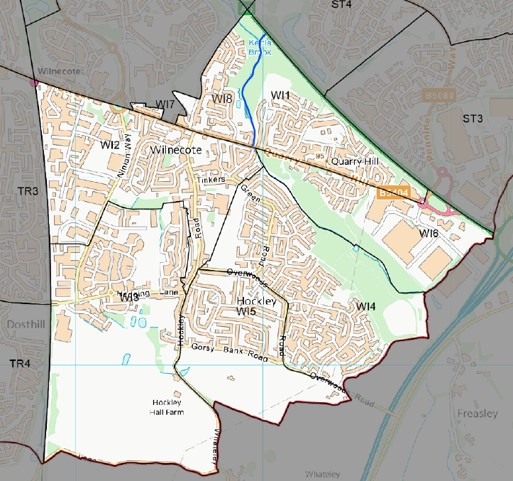

Polling District | Polling Station | Recommendations
WI1 | Wilnecote Junior Academy | Change.  Amend polling district boundary to create a new polling district to be known as WI8.
WI2 | Wilnecote Junior Academy | No change.
WI3 | Palmerston Avenue – Temporary Station | No change.
WI4 | Heathfields Infants Academy | No change.
WI5 | Heathfields Infants Academy | No change.
WI6 | Wilnecote Junior Academy | No change.
WI7 | Wilnecote Junior Academy | No change.
WI8 | Wilnecote Junior Academy | Creation.

However, due to County Council boundary changes the creation of a new polling district is required to ensure that next year’s County Council election can be run successfully and to allow for different types of election to be run on the same day. This new polling district will be called WI8 and will be made up of properties from the following streets that were originally in WI1:
- Glascote Lane
- Ninefoot Rise
- Church View
- The Hedgerows
- Shannon
- Watling Street (2 to 42 (a,b & c) and 78a, Field Lodge and Wilnecote Hall)
- Orkney Drive
- Arran Drive
- Shetland Avenue

The remaining polling districts will remain unchanged.

Wilnecote Ward Polling Stations

WI1, WI2, WI6 & WI7 – Wilnecote Junior Academy

WI3 – Palmerston Avenue Temporary Station

WI4 & WI5 – Heathfields Infant Academy

