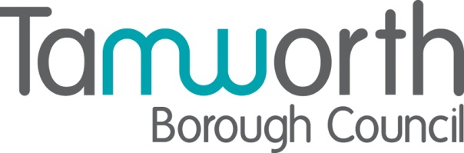

October 2024

Dear Supplier,

**Procurement Act 2023**

I am writing to you about the Procurement Act which achieved Royal Assent in the autumn of last year. This is an important piece of legislation which will revolutionise the way the public sector buys goods and services, bringing a range of benefits, including:

• Creating a simpler and more flexible commercial system that better meets our country’s needs while remaining compliant with our international obligations.

• Opening up public procurement to new entrants such as small businesses and social enterprises so that they can compete for and win more public contracts.

• Taking tougher action on underperforming suppliers and excluding suppliers who pose unacceptable risks.

• Embedding transparency throughout the commercial lifecycle so that the spending of taxpayers’ money can be properly scrutinised.

As a business which supplies goods, works or services to organisations in the public sector you need to know about these changes and our plans to prepare for go-live.

The new regime will commence on 24 February 2025. The existing rules will continue to apply for contracts that are already in progress, so the changes will not happen overnight.

For suppliers there will be new features which should make it easier to do business with contracting authorities:

• A central digital platform for suppliers to register, receive their unique reference number and store their details so that they can be used for multiple bids and see all opportunities in one place.

• Simplified bidding processes to make it easier to bid, negotiate and work in partnership with the public sector - including a new ‘competitive flexible’ procedure.

• Commercial frameworks will be more flexible, so prospective suppliers are not shut out for long periods of time.

• A new duty on contracting authorities to have regard to the particular barriers facing SMEs and VCSEs, and to consider what can be done to overcome them throughout the procurement lifecycle, helping level the playing field for smaller businesses so they can compete for more contracts.

• Strengthened provisions for prompt payment throughout the supply chain - enabling SMEs to benefit from 30-day payment terms on a broader range of public sector contracts.

• A stronger exclusions framework will take tougher action on underperforming suppliers.

These changes will drive innovation, deliver better outcomes and embed transparency right through the commercial lifecycle, so everyone can access procurement data and see how money is spent.

The Government Commercial Function will be providing a comprehensive training package for procurement practitioners in government departments and public bodies to ensure the benefits of the new regime are quickly realised and working with leading business groups and trade associations to make some of this training as well as guidance and support available for the suppliers.

There is already a range of information and resources about the new regime on the Transforming Public Procurement landing page including a series of ‘Knowledge Drop’ training videos with tailored versions designed specifically for suppliers, including SME and VCSE suppliers.

Materials will continue to be added and further resources added, as we move towards go live. In the meantime, there are actions you can start to take to prepare:

• Familiarise yourself with the Act - check out the summary documents and videos on the Transforming Public Procurement landing page and sign up for regular updates.

• Watch the dedicated official Knowledge Drops now available, with guidance, procurement reform events and supplier communications.

Here at Tamworth Borough Council, we are preparing by reviewing our pipeline, training our staff and exploring how Tamworth Borough Council’s requirements can benefit from the flexibilities of the new act.

In the meantime, if you would like to discuss any aspect of the new Act, please contact [procurement@tamworth.gov.uk](mailto:procurement@tamworth.gov.uk).

Kind Regards

Emma Dyer

Operations Accountant