**Disability Hate Crime**

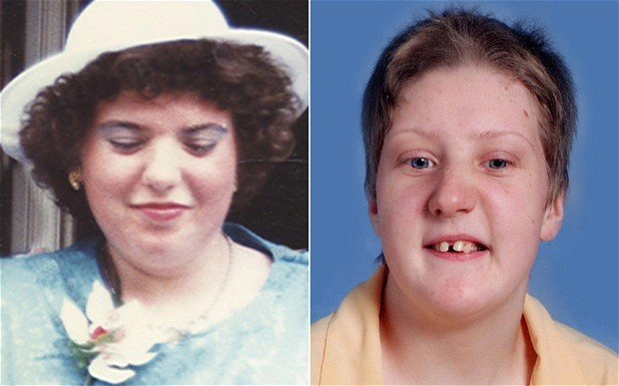

Fiona Pilkington and her daughter, Francesca Hardwick (pictured above), had severe learning disabilities and took their own lives after being targeted over a long period of time for being ‘different’.

As a result, agencies work in partnership sharing information about vulnerable people to stop this from happening in the future.

Disability Hate Crime can involve the following types of abuse:

* People throwing stones at my window
* People calling me names because I am different
* Someone borrowing my mobile phone and using up all the credit
* People beating me up outside the local shops and stealing my shopping
* People making friends with me then asking me to buy them things (commonly known as **‘mate crime’**)

**Mate crime** is used to describe people who make friends with you for their own benefit. For example taking over your home, eating your food and spending your money.

These are just a few examples. If you are being picked on because you are ‘different’, this can be a hate crime and can escalate to serious harassment, physical violence and sometimes death.

**Facts about Disability Hate Crime**

1. It is motivated by hatred, prejudice and ignorance
2. Nearly 90% of people with learning disabilities have been harassed or attacked, and almost a third experience this on a weekly basis.
3. 47% of people with learning difficulties do not feel safe in their own homes, or in the community and have a 20% chance of being attacked
4. Hate crime can cause significant damage to the people who experience it and their communities
5. Disability Hate Crime is a criminal offence under section 146 of the Criminal Justice Act 2003
6. Disability is a protected characteristic under the Equality Act 2010

Tamworth Borough Council works actively with **Uniting Staffordshire Against Hate** to provide support for victims of hate.

You can self refer to this service in the following ways:

By phone on: 0330 0881 339

By email on [help@staffsvictimsgateway.org.uk](mailto:help@staffsvictimsgateway.org.uk) or staffs.victimsgateway@snscab.cjsm.net

By website [www.staffsvictimsgateway.org.uk](http://www.staffsvictimsgateway.org.uk)

*If you’re not comfortable calling somebody new,*

*talk to somebody you trust about how you feel.*

If you fear for your immediate safety, call **999**.

If you are suffering any type of abuse, you can report this to Staffordshire Police on 101 or online at [www.staffordshire.police.uk](http://www.staffordshire.police.uk).

You can also make a report to Tamworth Borough Council at [neighbourhoodimpactteam@tamworth.gov.uk](mailto:neighbourhoodimpactteam@tamworth.gov.uk).

If you are concerned that an adult with care and support needs is experiencing or is at risk of abuse or neglect, please pass this information to the Staffordshire County Council's Adult Safeguarding Team on 0345 6042719 (Monday to Thursday, 8:30am-4:30pm, excluding Bank Holidays. Telephone 0345 6042886 at any other time).