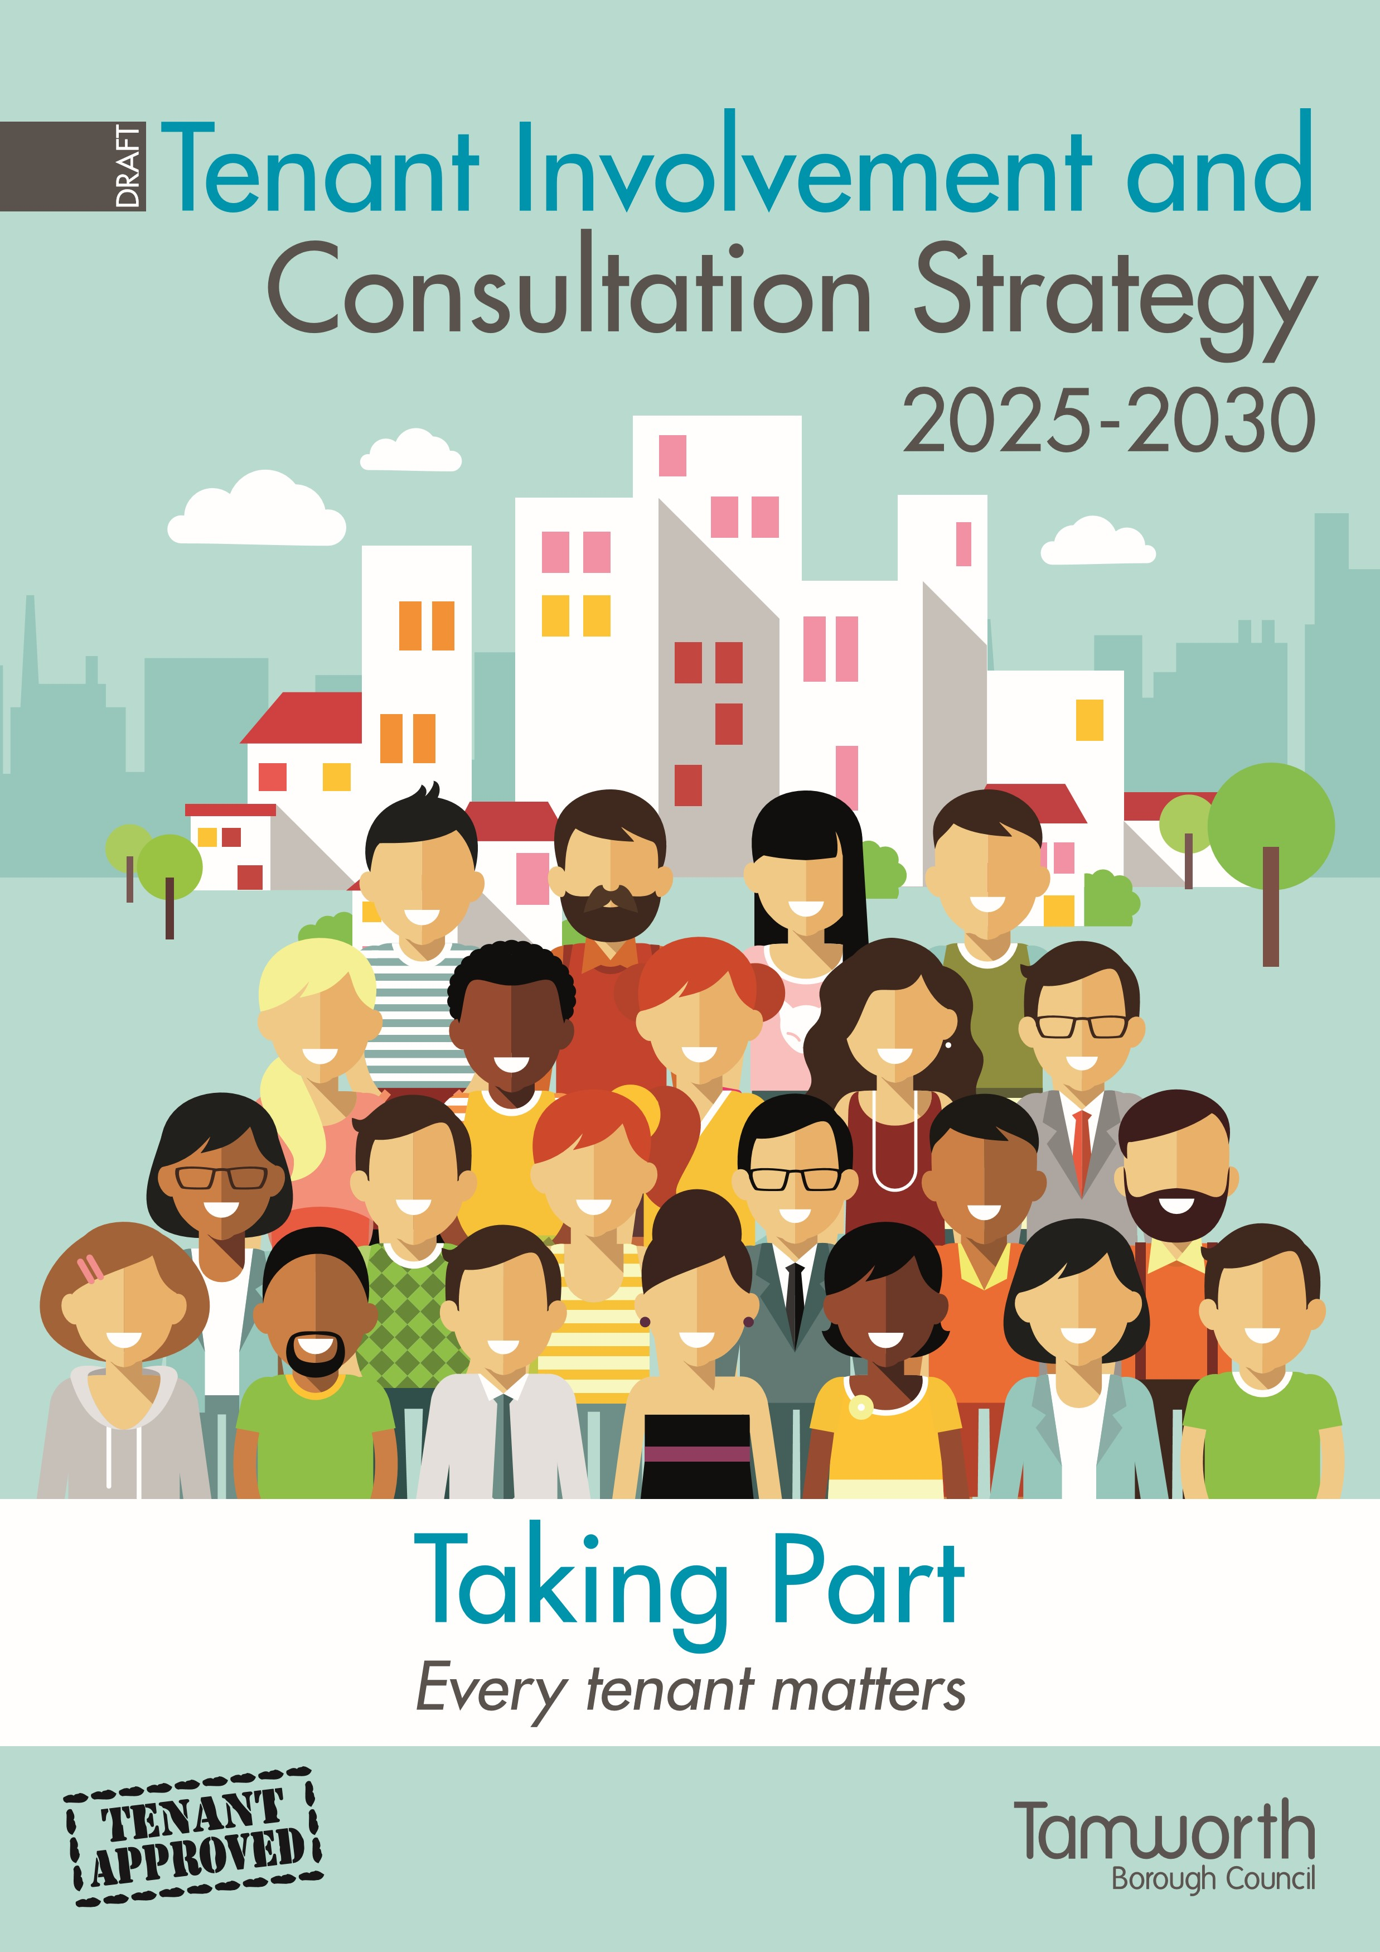

# Contents

**Page no**

Introduction & Joint Foreword 4

Vision & Mission 5

The Tenant Journey 5

Principles & Core Values 5

Objectives 7

Achievements so far 7

Getting Involved 8

Building on the Success of our Current Involvement Structure 9

Formal Involvement 9

Informal Involvement 10

Tenant Involvement & Co-Regulation – how it all fits together 12

Strengthening our Approach 13

What success will look like 16

Resources and Support 17

Action Plan 17

Let us know what you think 21

**Have Your Voice Heard**

We ask you to thoroughly review this draft document at the tenant’s conference, you are invited to participate in discussions and share your feedback.

Your input is crucial in ensuring that this strategy reflects your needs and preferences. We encourage you to tell us whether you agree or disagree with different aspects of the strategy and let us have your suggestions for any improvement. Together, we can create a robust, inclusive, and effective engagement framework that truly represents the voices of our Tamworth community.

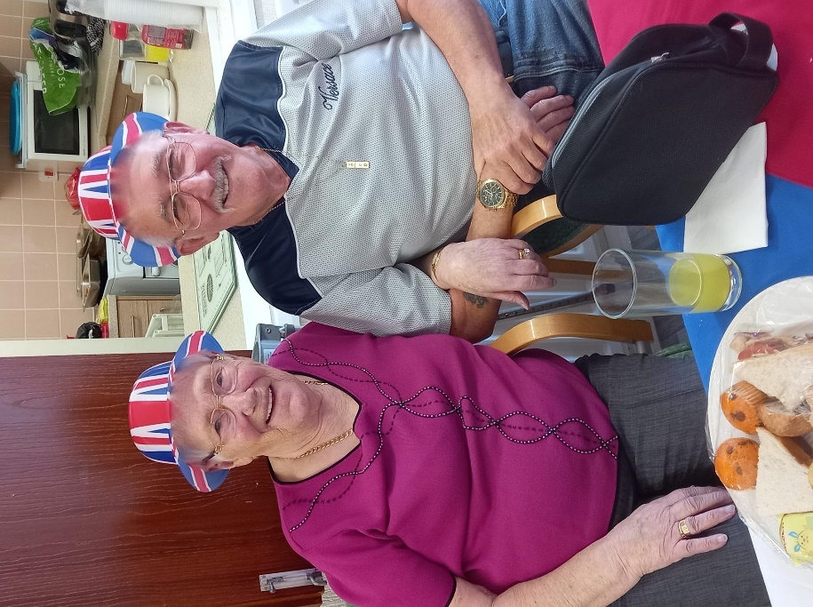 

**Introduction**

We believe that including the opinions and thoughts of our tenants, within our decision-making process, is key in building a successful housing service which works well for everyone.

Tamworth’s Tenant Involvement & Consultation Strategy 2025-2030 aims to create an inclusive, transparent, and effective framework for tenant involvement. This strategy builds on previous achievements and aligns with regulatory standards, including the Regulator of Social Housing's ‘Transparency, Influence, and Accountability’ Standard. The government recognises how important it is that landlords listen to what their tenants have to say and have introduced new rules and regulations which they must follow. The regulator will be checking that we are doing all that we can to listen to, and consider the views of as many, and as wide a range of our tenants as we can. Guided by principles of fairness and respect, our mission is to empower tenants, work together, and ensure that tenants’ voices are central to our decision-making processes.

In this strategy, the term ‘tenant’ encompasses, tenants, leaseholders, and their family members, ensuring that all voices within our community are heard and represented.

This strategy explains our plans for the next five years to help tenants become more involved in their housing service. It covers both new and improved ways to do this and compliments Tamworth Borough Council’s strategic priorities *Tamworth - celebrating our heritage, creating a better future.*

**Joint Foreword**

Joint foreword by Councillor Ben Clarke**, Portfolio Holder**for**Housing,** Homelessness and Planning and Iris Clements, Tenant Consultative Chair.

“We are extremely grateful for the time and effort tenants give in helping the council to understand their needs and aspirations. We continue to work closely together, sharing information and developing our housing service. Transparency with our tenants is very important with a very challenging future ahead of us”

This is the first refresh of our Tenant Involvement & Consultation Strategy following its review back in 2020. We feel that this strategy provides us with the principles respond positively to the expectations of the consumer regulation being developed as part of the future direction of Social Housing Regulation. This strategy enables us to respond to changes to the regulations, which place an emphasis on the importance of tenants being listened to and being able to hold their landlord to account. We recognise the work of all tenants that have been part of delivering our initial strategy and for their commitment and time given to develop and improve our housing services. We also thank them for helping to shape the future direction of our tenant engagement opportunities and look forward to working with them to ensure that this strategy remains fit for purpose in this changing and challenging environment for social housing. This strategy formally reinforces our commitment to involving tenants in shaping the services that Tamworth provides.

**Vision**

To empower tenants to shape and influence the services they receive, ensuring that their voices are heard and acted upon.

To achieve our vision, we must listen to what our tenants tell us. We have had conversations with some tenants who are already involved and some who are not. We have also spoken to housing staff and councilors to find out what good tenant engagement and involvement looks like. We have adopted their ideas in the development of this strategy.

**Mission**

To create a transparent, inclusive, and responsive engagement framework that places tenants at the heart of our operations. Adopting a joint working environment where tenant’s feedback and insight drives continuous improvement.

**The Tenant Journey**

|  |  |
| --- | --- |
|  | **Tenant Co-design Journey** |
| **Foundations** | Co-design housing services with tenants |
| **Front door** | Service accessibility for tenants |
| **Windows** | Tenant insight |
| **Ground & first floor** | Tenant information, consultation, involvement & empowerment |
| **Chimney** | Tenant insight & flow of information |

**Foundation:**

The foundation of the house represents housing services and tenants **working together** to improve the quality of services for everyone.

.

**Windows:**

The windows represent **insight** into a thorough understanding of housing services.

**Levels:**

The different floors of the house represent varying **engagement levels**:

* Information
* Consultation
* Engagement/Involvement
* Empowerment

**Doors:**

The door represents **accessibility**, how tenants can enter and participate in the engagement process.

**Chimney:**

The chimney represents **flow**, representing the flow of information produced leading to more effective and relevant policies and services.

**Golden Thread:**

There will be a **Golden Thread** running through the house, connecting all levels and elements. This thread represents the core values and principles of housing services, ensuring coherence and consistency throughout the engagement process.

**Principles and Core Values**

**Your voice in every choice:** We make tenant feedback a necessary condition for approval, ensuring their voices guide our decisions.

**Meaningful engagement in every interaction:** We guarantee that all interactions with tenants are purposeful and contribute positively to their engagement and satisfaction, recognising each contact as an opportunity to enhance tenants’ experience.

**Tenant first culture:** We will maintain clear expectations for a tenant-first culture and consistently offer opportunities to enhance tenants’ community engagement skills.

**Fair and respectful treatment:** We are dedicated to treating all tenants with fairness and respect in every interaction, ensuring diverse needs are met and dignity is upheld.

**

**Objectives**

* **Transparency**: Build trust through openness in our actions and activities.
* **Influence**: Provide different ways for tenants to shape the way Tamworth Borough Council operates.
* **Accountability**: Ensure we are answerable for the decisions we make and the impact on tenants.
* **Achievements** - Building on our foundations.

This latest Tenant Involvement Strategy builds on existing achievements by tenants and staff, working together to develop and improve tenant engagement throughout Tamworth borough.

**Achievements so far**

* Tenants have reviewed proposals for the Neighbourhood Investment Programme and agreed priority works for 2024-2025.
* The Tenant Consultative Group (TCG) attended several workshops in 2023-2024 to discuss and review the council’s Self-Assessment Improvement Plan, to ensure compliance against the social housing regulatory standards.
* TCG actively tested and provided crucial feedback on the introduction of the ‘myhousing’ portal, prior to its live launch.
* The Chair and Vice Chair of TCG have sat on the Housing and Homelessness Advisory Board meetings.
* Tenants have contributed to the development and review of key publications to include the High Rise Health & Safety booklet, Annual Report to tenants, Open House tenant’s quarterly newsletter and Paying Your Rent leaflet.
* Tenant Inspectors have actively been involved in an annual programme of communal cleaning checks and estate inspections.
* TCG representatives met with Tony Newman, a Housing Quality Network Associate, to discuss their involvement on income related policies and practices and other aspects of income related work. This is part of the HQN Accreditation: MIST – Maximising Income, Sustaining Tenancies.
* Tenants have been engaged with the following key consultation over recent years: Neighbourhoods Tenancy Management Plan, the Corporate Comments, Compliments and Complaints Policy, the Repairs Policy, the Annual Report to Tenants, the High Rise Health and Safety Guide and the Income Management Policy.
* A High-Rise Tenant Consultant Group has successfully been introduced to look at challenges specific to high rise living, including communication, engagement, health & safety, communal cleaning and tenancy and environmental issues.
* Guest speakers at TCG meetings have included representatives from; Street Scene to talk about environmental standards, The Information & Governance Team to share updates on the Housing Ombudsman Complaint Handling Code, the Leisure Team to discuss engagement opportunities locally, the Repairs Team to discuss the Repairs policy and how problems associated with damp and mold are investigated and actioned. We also had the Corporate Communications Team visit to share information and request feedback on proposals for the new Tamworth Borough Council website.

**Getting Involved**

**Why tenants should get involved.** We want to provide the best service we can, and to do that we need help from our tenants. Tenants living in the Tamworth borough have first-hand experience of services delivered to them. By tenants telling us what they think works well, or where we can improve, they are giving us the feedback we need to help improve services for everyone.

**What experience tenants need.** Tenants already have all the experience they need to get involved. Tenants are experiencing our services first hand, and the feedback on these experiences is what we are looking for to make housing services the best they can be.

**What support will tenants get.** We can offer training and support if tenants feel they need it to get involved. This will be different however for everyone. Tenants can come along, join in, and try any of our groups or activities before they commit. If someone just wants to come along and watch to start with then that’s ok with us. Different involvement will suit different people and their circumstances, and we fully understand this. We commit to ensuring our approach to tenant involvement is flexible to suit individual needs.

**Ways to get involved** We have lots of different ways for tenants to find out more about their Housing Service and how they can have their say. We have put together a menu of tenant involvement activities that tenants can choose from. Many involvement options only ask for a small amount of time, as and when. Others ask for larger and more regular time commitments. Whichever option is chosen, tenants will be playing a very important part in helping us make the Housing Service work for everyone.

**Building on the Success of our Current Involvement Structure**

**Formal Involvement**

Formally involved tenants are our critical friends. They not only oversee the journey of the tenant voice but, also rigorously evaluate performance and ensure compliance with regulatory consumer standards. In addition to their ongoing scrutiny, they will conduct in-depth reviews independently. To strengthen our working together arrangements, these groups will play a more integral role within our governance structure, adopting stronger connections with the Council. To support this effort, we will be establishing a Tenant Advocate role.

**Tenant Consultative Group (TCG)**

TCG provides a united voice for tenants to discuss a range of issues and get involved in the decision-making process to improve housing services for all. The group is consulted on a wide range of housing related policies, practices and procedures.

**Tenant Involvement Group (TIG)**

TIG monitors the actions and performance against the aims in the Tenant Involvement and Consultation Strategy. This group also monitors customer feedback, satisfaction and any performance related information.

**Scrutiny Panel**

The scrutiny panel will collect evidence to enable a housing service area to be scrutinised. They will examine the evidence and make recommendations for service improvements

**Informal Involvement**

**Informal Involvement**

More informal involvement with Tamworth offers flexibility, inclusivity, and a range of engagement opportunities that cater for the diverse needs of tenants. It allows for continuous feedback, trust and assurance that all voices are considered in decision-making processes. ​This may include:

**Complaints Review Panel**: Reviews complaints and housing member enquiries, identifying trends and common themes and making recommendations for service improvements.

**Seniors United**: A forum for sheltered housing tenants to share ideas and discuss relevant issues to sheltered living.

**High Rise Tenant Consultant Group:** This group will meet to discuss and consult with the council on a variety of issues unique to high rise living

**Estate inspections**: Regular annual inspections by tenants and Neighbourhood Service staff, to assess the condition of estates and communal cleaning and identify areas for improvement.

**Digital panels and focus groups**: Online platforms for tenants to participate in discussions and provide feedback on assorted topics.

**Digital workshops and polls**: Virtual sessions and surveys to engage tenants in decision-making processes.

**Mobile apps and online forums**: Tools to facilitate easy communication and feedback between tenants and the council.

**Smart technologies**: Implementing technologies that allow tenants to report issues and track service requests digitally.

**One-on-one interactions**: Personalised strategies to address individual tenant needs, ensuring their preferences are met.

**Tenant champion programme**: Tenant champions will act as liaisons between the council and the tenant community, particularly focusing on quieter voices.

**Mystery shopping**: Evaluates service quality through hidden testing, ensuring that services meet necessary standards.

**HIGH ENGAGEMENT**

**Empowerment**

Tenant Consultative Group

**Engagement/Involvement**

Tenants Scrutiny Panel

Tenant Involvement Group

Complaints Review Panel

ASB Scrutiny Group

Tenant Inspectors

Seniors United

Tenants Voice Editorial Panel

High Rise Tenant Consultative Group

Digital online forums, workshops, focus groups, surveys, polls

**Consultation**

Tenants Conference

Focus Groups, surveys, consultation, workshops, awareness sessions,

community estate-based events, open days,

Mobile apps, digital polls, online forums.

**Information**

Open House (Tenants e-newsletter)

Annual Report

Website

Social media

WhatsApp

**LOW ENGAGEMENT**

**Tenant Involvement and Co-Regulation – How it all fits together**

C**o**-regulation, working together, is continually developing. This not only involves an important relationship between housing providers and their regulator, but self-assessment and tenant involvement is also a key element, turning regulatory compliance into a collective responsibility.

Our structure for tenant involvement tries to ensure that our tenants are involved at all levels of the council and can give their feedback and views in a variety of ways.

The below diagram illustrates tenant involvement in shaping, influencing and scrutinising services. The Tenant Consultative Group (TCG) are consulted on any housing service policy change prior to a decision being made by Cabinet.

Part of the co-regulatory requirement is for housing providers to involve their tenants in scrutinising services and undertaking service reviews as part of service improvement groups. To play their part effectively, it is vital that tenants are confident and equipped with the skills and knowledge required to undertake this role.

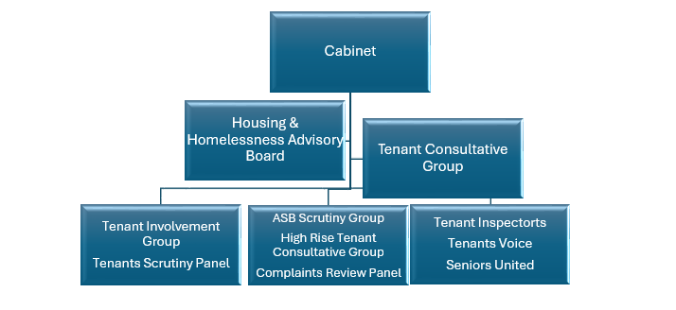

**Strengthening our Approach**

Our strong ‘let’s work together’ approach will be enhanced by increasing tenant involvement through our new framework. We will introduce and use innovative digital tools such as mobile apps, online forums and smart technologies to enhance our informal engagement with tenants, ensuring we reach a diverse audience and effectively respond to feedback. Personalised engagement through updated tenant profiles and regular one-on-one interactions will also allow us to address individual needs.

We will ensure transparent feedback processes and develop targeted approaches to engage quieter voices, removing barriers to participation and ensuring fairness and respect. Additionally, we will offer a training programme and involve tenants in service design and community improvement projects, while continuously monitoring and improving our strategy based on feedback.

1. **Let’s do It better together**

We are committed to further embedding our working together approach, at the heart of our service delivery. By involving tenants in the design and implementation of services, we ensure that their voices are central to our decision-making processes.

**Let’s do it better together principles**:

* Creating an environment where tenants feel comfortable voicing their opinions, by holding meetings in community settings and ensuring staff are responsive to feedback and recommendations.
* Encouraging open and honest feedback from tenants.
* Engaging tenants from the very beginning of projects to shape the scope and direction based on their experiences and insights.

**Involving tenants in the design and implementation of service changes:**

* Work together to create job profiles involving tenants in neighbourhood staff recruitment.
* Involve tenants in service design and review.
* Involve tenants in designing and leading training.
* Develop behaviour-based service standards.

**Encouraging tenant-led community improvement projects:**

* Support tenant-led community projects through our Environmental Investment Programme.
* Offering training sessions and workshops to build tenants’ skills in project management, leadership, and community engagement.

1. **Innovative digital tools**

We believe that growing our digital engagement will enable us to expand our reach to more tenants and improve the overall quality of tenant involvement. By going digital, we can engage more tenants, on their terms, and respond effectively to both individual and collective feedback, ensuring we hear diverse voices within the community.

**Mobile apps, online forums, and smart technologies to enhance digital engagement:**

* Running digital panels and focus groups.
* Establishing digital workshops, digital polls, and digital service testers.
* Creating engaging user-friendly digital content such as videos, infographics, and interactive guides.
* Utilising social media platforms to share updates, gather feedback, and promote tenant participation.
* Offering access to digital devices and internet connections for tenants who may lack these resources.

**Digital inclusion training to ensure all tenants can participate effectively:**

* Enhancing digital inclusion through training to improve skills and confidence to use online and digital services.
* Offering virtual tours and webinars to provide tenants with a comprehensive understanding of council services and initiatives.

1. **Personalised engagement**

We are committed to refreshing and updating tenant profile information to ensure tenants feel recognised as individuals. By Keeping profile information current, including communication and involvement preferences to better meet tenant expectations.

**Building stronger relationships through regular updates:**

* Engaging tenants in meaningful, everyday conversations to build stronger relationships.
* Using everyday one-on-one interactions as opportunities to better understand our tenants' needs and preferences.

1. **Transparent feedback processes**

We will be clearer about how the tenant voice has influenced our learning and decision-making processes.

**Clearly communicating how tenant feedback influences decisions:**

**Your Voice in Every Choice.**

* Ensuring tenant input is a necessary condition for approval, guiding our decisions.
* Implementing a "You Said, We Did" approach to demonstrate the impact of tenant contributions.
* Clearly showing how tenant feedback has led to specific actions and changes.
* Conducting regular surveys to gather ongoing feedback on services and engagement efforts, ensuring continuous improvement.

**Quality and responsive communication:**

* Providing communication to all tenants in a range of formats, ensuring accessibility and responsiveness.
* Utilising mobile apps or online platforms for real-time tenant feedback to demonstrate how tenant input influences decisions.

**Proactive analysis of complaint data:**

* Analysing complaint data to identify and address common themes and trends proactively.

1. **Inclusive outreach**

We will develop innovative approaches for reaching those we don’t hear from regularly and removing any barriers to engagement.

**Developing targeted approaches to engage less active tenant voices:**

* Reach out to traditionally quieter voices, ensuring their perspectives are heard and respected.
* Identify and remove barriers that prevent tenants from getting involved. i.e. providing transport, providing information in a range of formats, supplying large print material or helix magnifying sheets, using venues that are convenient and accessible.
* Develop communication strategies tailored to different groups, ensuring information is accessible to tenants with language barriers, disabilities, or other specific needs.
* Offer support services to help tenants navigate and use housing services, potentially including dedicated advocates or representatives for vulnerable groups.
* Provide multiple engagement platforms, offering numerous ways for tenants to participate, such as online forums, virtual meetings, and in-person gatherings, to cater to different preferences and accessibility needs.
* Establish a program where tenant ambassadors or tenant champions from various communities can help bridge the gap between the council and quieter voices.

**Conducting regular ‘getting to know your activities’ to understand and address diverse needs:**

* Participate in local area community events.
* Support regular community engagement activities.

1. **Empowerment through training**

Recognising the importance of training for both tenants and staff, adopt a tenant-first culture, enhance engagement, and ensure effective participation in decision-making processes. To achieve this, we will focus on comprehensive training programs, digital literacy, and capacity-building initiatives.

**Comprehensive Training Programs:**

* Develop tailored training programs that cover all aspects of involvement for both tenants and staff.
* Provide adequate resources to support these training initiatives, ensuring both groups are well-equipped to participate meaningfully.

**Tenant Training Academy:**

* Establish an accredited Tenant Training Academy offering courses on housing operations and governance.
* Deliver a range of training opportunities, including housing-specific and digital skills training.

**What Success Will Look Like**

**Transparency: Build trust through openness in our actions and activities.**

**Robust feedback mechanisms:** We will regularly publish performance data and feedback outcomes, clearly communicating how tenant feedback influences decisions through our "You Said We Did" approach.

**Regular reporting on complaints:** Include regular reports on the types of complaints received and how they have been addressed, along with any changes made as a result.

**Performance monitoring and continuous improvement:** We will conduct regular performance monitoring and reporting with annual reviews and adaptations of the strategy based on tenant feedback. We will provide transparent communication on performance targets, achievements, key successes, and updates on involvement activities.

**Influence: Provide mechanisms for tenants to shape the way Tamworth Borough Council operates.**

**Inclusive and diverse engagement:** we will aim to ensure broad representation and involvement from all areas of the community, developing targeted approaches to engage quieter voices and removing any barriers to participation.

**TPAS accreditation:** We will aim to achieve accreditation for tenant participation and scrutiny, demonstrating our commitment to involving tenants in decision-making processes.

**Accountability: Ensure we are answerable for the decisions we make and their impacts on tenants.**

**Increased tenant satisfaction:** We will aim for high tenant satisfaction and ensure that we listen and act on tenants’ views and treat them with fairness and respect.

**Enhanced digital engagement:** We will increase the number of tenants accessing services digitally, ensuring they have the skills and confidence to use online and digital services.

**Resources and Support**

To encourage the development of individuals and groups in all areas of tenant involvement, we recognise the importance of providing sufficient staffing, resources, support and learning opportunities.

We will:

* Provide a dedicated Tenant Regulatory & Involvement Team who will help support the work of tenants and staff to meet this strategy’s aims.
* Offer skills development and a dedicated training programme in the form of learning opportunities and information awareness sessions.
* Ensure there is sufficient funding to support tenant involvement activities carried out locally for consultation, involved working groups, development opportunities and estate-based events.
* Provide any specialist services e.g. signers for British Sign Language.
* Provide travelling expenses, if required, to and from venues for the purpose of any tenant involvement activity.

**Action Plan**

**Aim one – Understanding our tenants**

We will:

* Build a clearer picture of who our tenants are and gain a better understanding of their needs through surveys, tenancy visits and partnership working.
* Find out how our tenants would prefer to be contacted and how they would like to get in contact with us.
* Promote equality within our services and remove any barriers.

**Our Action Plan**

By 2029 we aim to:

* Complete a tenant ‘Getting to know you survey’
* Undertake an analysis of our tenants in the area that they live, to better develop engagement, consultation and community development that’s suits tenants best.

**Aim two – Improving the value of tenant involvement**

We will:

* Give tenants the training and skills that they need to get the most out of working with us.
* Ensure that the time tenants give to help us make changes, is valued and purposeful.
* Ensure that involved tenants fully understand what is expected of them and what they can expect from us in return.
* Ensure that time spent with staff is productive and useful.
* Share all information with tenants in a clear concise way that is clearly understood and is jargon free.
* Not expect tenants to read through pages of jargon and figures. All information will be summarised so it is clearly understood to ensure productive involvement.
* Update tenants of any changes as a result of their input and feedback.

**Our Action Plan**

By 2029 we aim to:

* Help tenants with understanding of information, reports and data.
* Create a clear training plan for tenants.
* Review the terms of reference for appropriate involved groups.
* Develop and agree an annual scrutiny plan.
* Develop key performance indicators for tenant involvement.
* Share housing services key performance indicators with relevant involved groups.
* Produce an annual tenant involvement performance report of involved groups, achievements and involvement plans for the forthcoming year.
* Produce an annual tenant involvement impact assessment of all tenant involvement activity within housing services.

**Aim three - Increasing the diversity of our involved tenants**

We will:

* Identify which groups of tenants are not sharing their thoughts and experiences with us.
* Enhance targeted plans to improve relations with those tenants and encourage more of them to become involved.
* Make greater use of social media and online methods to make it easier for younger, working and hard to reach tenants to have their say.

**Our Action Plan:**

By 2029 we aim to:

* Recruit new members to our involved groups through varied involvement activities.
* Investigate online meeting options for our involved tenant groups where needed.
* Adapt our communication with tenants in line with the findings from our ‘getting to know you’ survey.
* Begin the process of developing tenant ‘champions.
* Use the results from our ‘getting to know you’ survey to identify groups and communities and find the most relevant partnership agencies to work with to improve both communication and engagement with them.
* Develop a clear plan for recruiting tenants onto our involved groups.
* Provide all new members with an involvement welcome pack.
* Promote the positive outcomes of tenant involvement on our website, social media, annual impact assessment, annual report to tenants and Open House, tenant’s quarterly newsletter.
* Include tenant involvement performance as part of the annual report to tenants.
* Promote involvement to all new tenants using the new tenant introductory letter.
* Explore the use of incentives for getting other tenants and hard to reach tenants involved.

**Aim four - improving our communication and consultation with tenants**

We will:

* Find out how our tenants would like us to contact them, and how they prefer to communicate with us.
* Tailor our services to meet these contact preferences where possible.
* Make greater use of social media and online methods to consult with our tenants, to make it easier for more tenants to have their say.
* Not use jargon when we are talking to our tenants and keep things simple and meaningful.

**Our action plan:**

By 2029 we aim to:

* Make sure reports produced by housing services management include information about consultations with tenants.
* Implement a digital inclusion programme.
* Increase tenant involvement through online surveys, online chat, WhatsApp and social media.
* Use the results of our ‘getting to know you’ survey to help develop a targeted plan to actively engage with under-represented groups, using their preferred communication method.
* Provide information to tenants which is relevant and easy to understand.

**Aim five - value our involved tenants**

We will:

* Consider an incentivised approach to tenant involvement to determine if more needs to be done to encourage others to take part.
* Organise a bi-annual tenants’ conference/event to highlight, appreciate and celebrate our involved tenants.
* Look at the different areas within our borough to check that all are represented and included within our service deliver.

**Our action plan**

By 2029 we aim to:

* Work with residents to provide a bi-annual tenants conference or celebratory event.
* Consider the inclusion of reward incentives to increase levels of resident involvement.

**Have your voice heard**

If you are one of Tamworth Borough Council tenants and would like the opportunity to get involved, then please contact us on 01827 709709 or email: [tenantparticipation@tamworth.gov.uk](mailto:tenantparticipation@tamworth.gov.uk)

**Thank You**

Thank you to all the tenant involvement working groups and other tenants who have given us their views about getting involved at Tamworth Borough Council. Without your help this document could not have been produced

**Hey! Please let us know what you think. We would love to hear your views.**